Nikola Jovanović 25/20

<https://nikolajovanovic123.github.io/pullo/index.html>

**1.Uvod** **3**

1.1Koriscene tehnike 3

1.2Template 3

1.3Organizacija stranica 3

**2.Opis stranica** **4**

2.1Index 4

2.2Shop 6

2.3Cart 11

**3.Kodovi** **13**

3.1 index 13

3.2 shop 33

3.3 cart 45

3.4 css 53

3.5 main.js 87

3.6 main2.js 98

3.7 producers.json 120

3.8 products.json 121

# 1.Uvod

## 1.1Koriscene tehnike

Prilikom izrade sajta korišćeni su jezici HTML ,CSS,JavaScript.JQuery I Bootstrap.

## 1.2Template

Prilikom izrade sajta korišćen je free template sa interneta.

## 1.3Organizacija stranica



# 2.Opis stranica

## 2.1Index

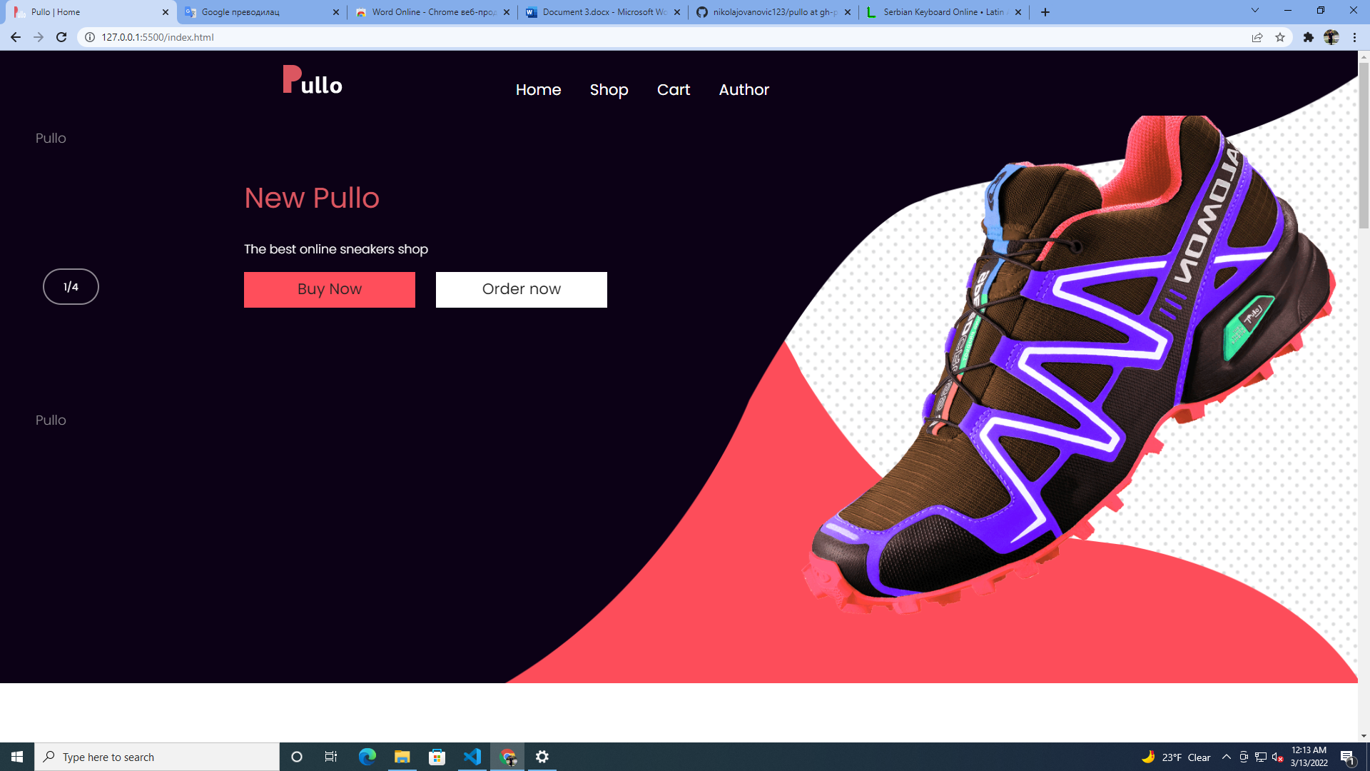

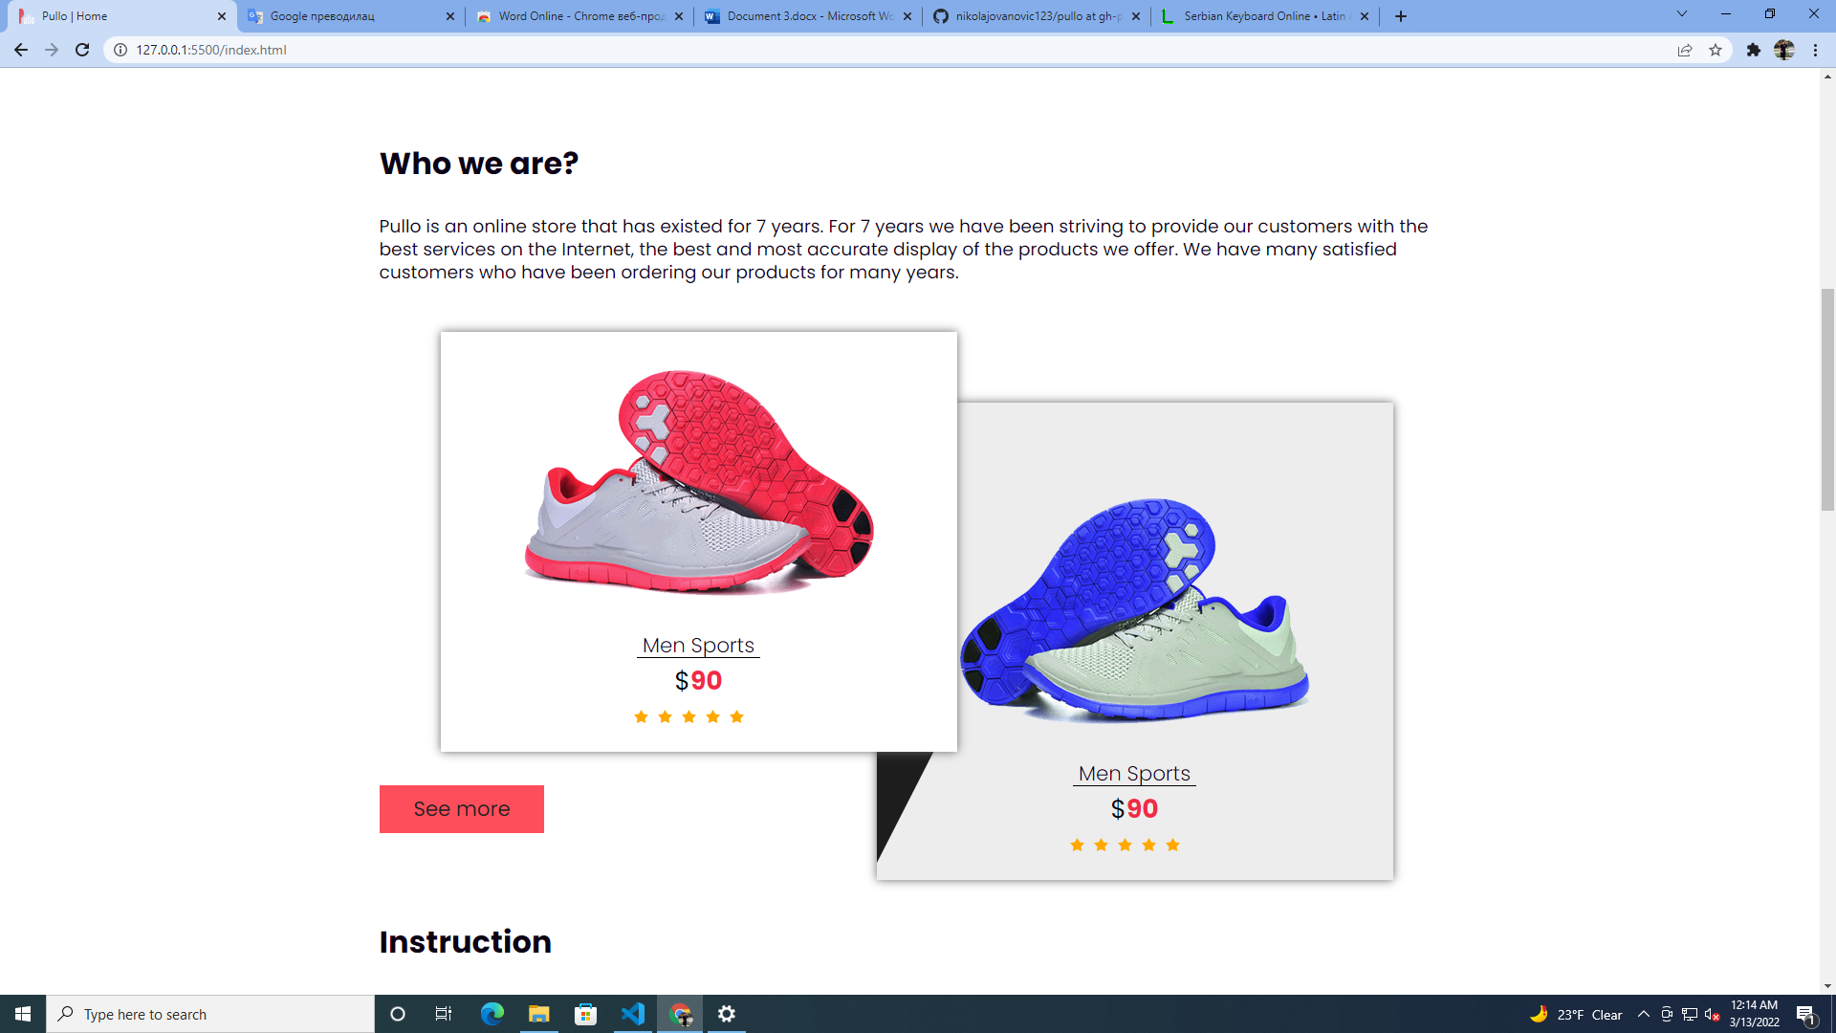

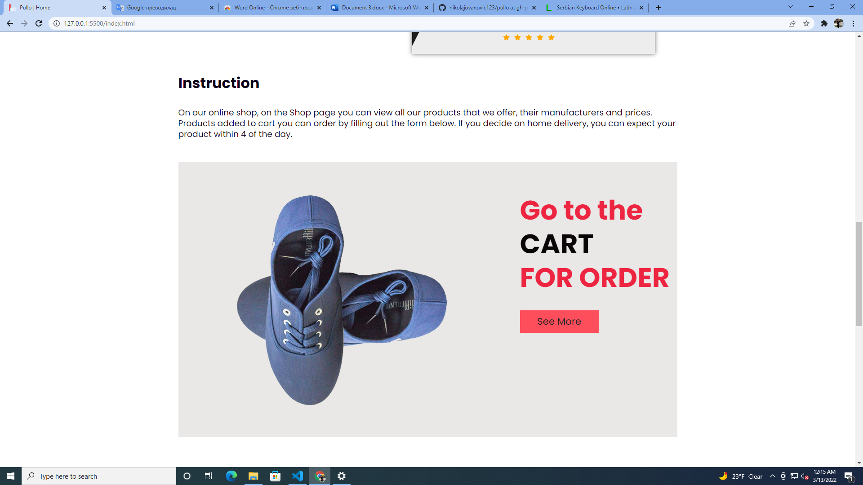

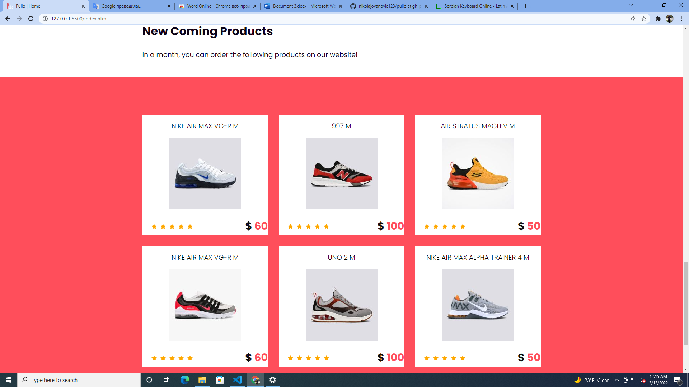

-> Stranica index je stranica koja predstavlja uvod u ostatak sajta

-> Na njoj su smešteni linkovi ka ostalim stranicama

->Menu I div sa dolazećim proizvodima su ispisani dinamički

## 2.2Shop

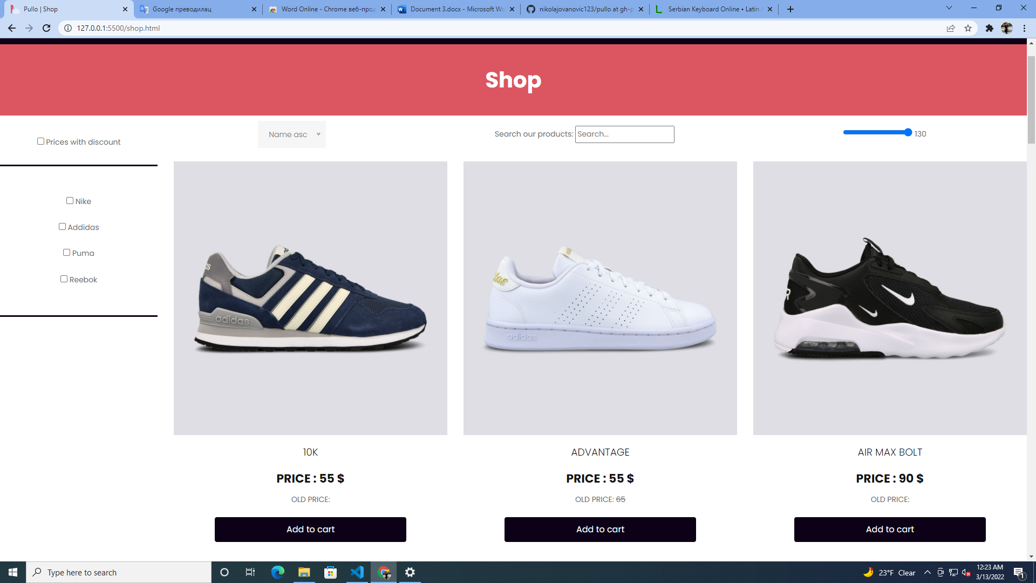

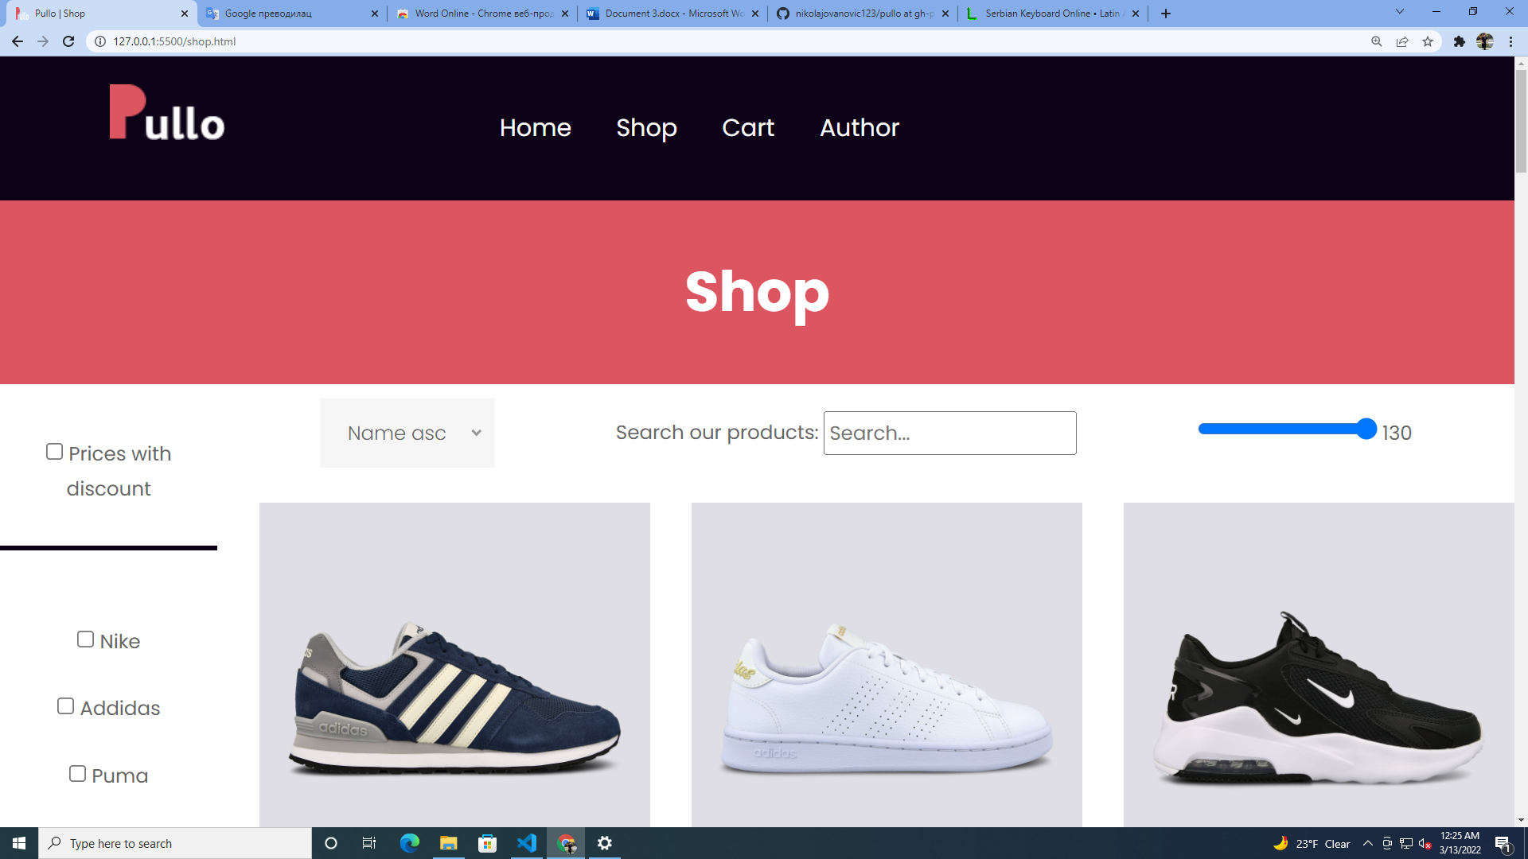

->Marke se dinamički ispisuju pri ucitavanju stranice

->Prilikom čekiranja marke ,proizvodi,koji su ovog puta učitani iz posebnog JSON fajla se filtriraju :

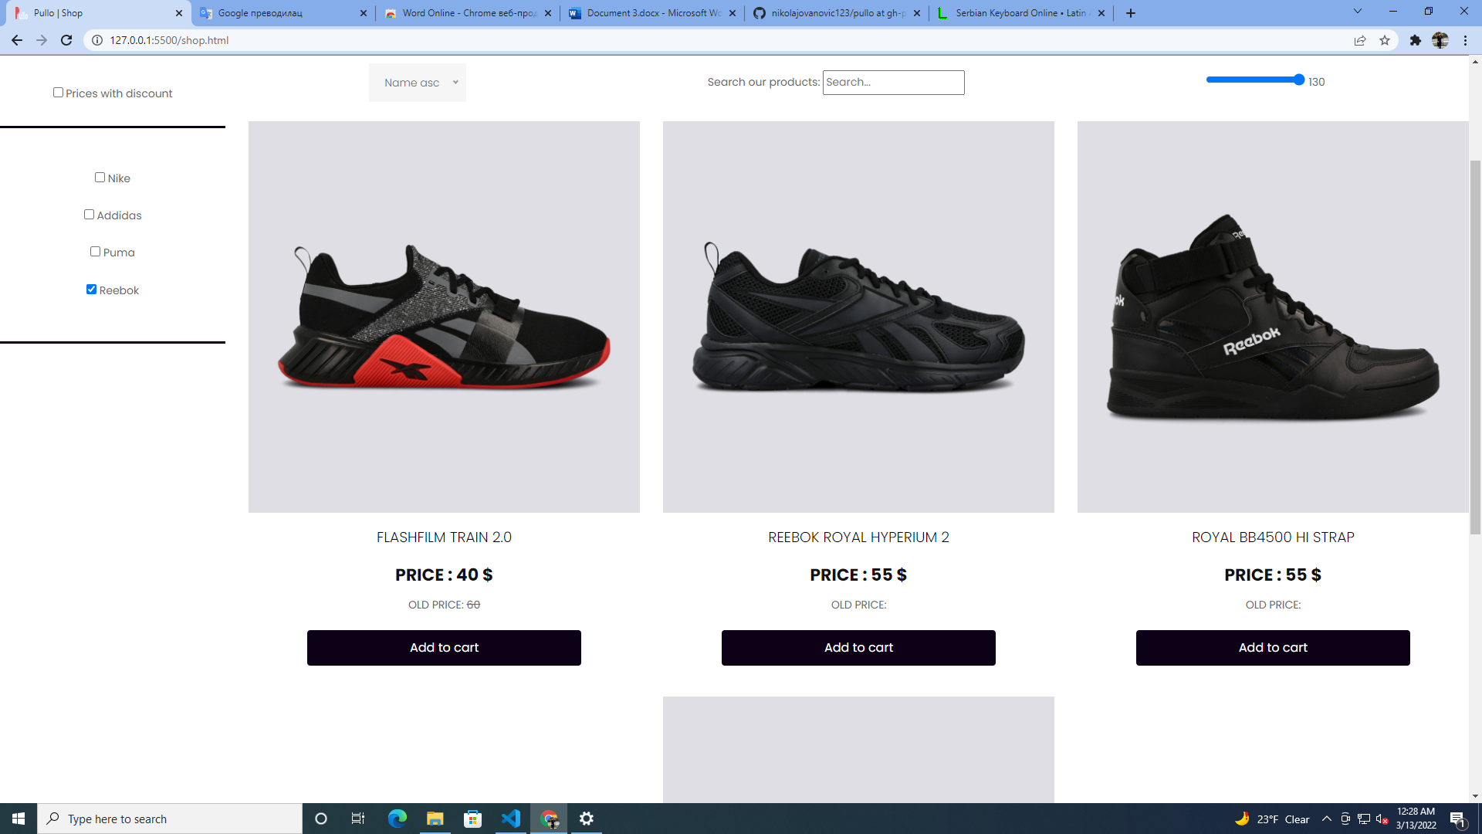

->Takođe je dozvoljeno filtriranje proizvoda sa popustom na ceni

->Select dozvoljava filtriranje proizvoda po ceni od najmanje ka najvecoj I obrnuto ili po imenu proizvoda A-Z ili Z-A.

->Ukucavanjem imena proizvoda u textbox radi se filtriranje proizvoda po njegovom imenu.

->Input range dozvoljava filtriranje proizvoda po njihovoj trenutnoj ceni.

->U slučaju da funkcije ne vracaju ni jedan proizvod ispisuje se poruka na stranici:

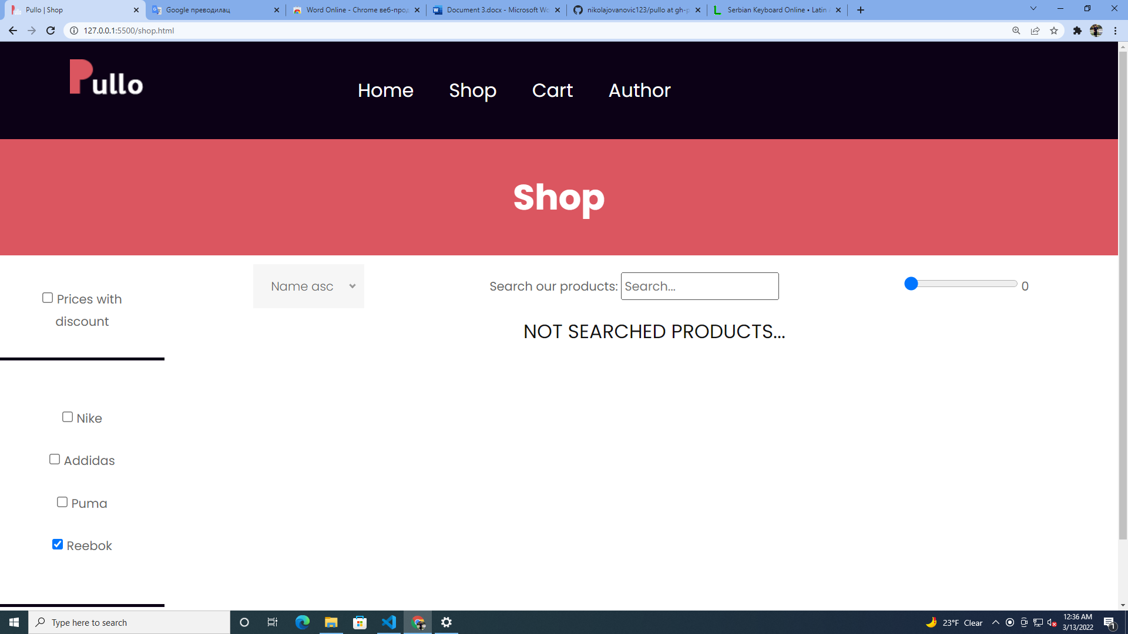

->Klikom na dugme Add to cart ,taj proizvod se dodaje u korisnikovu korpu

->Potom korisnik dobija poruku o tome:

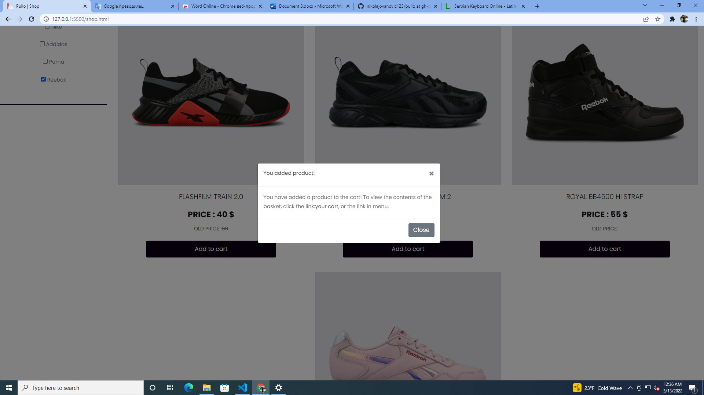

## 2.3Cart

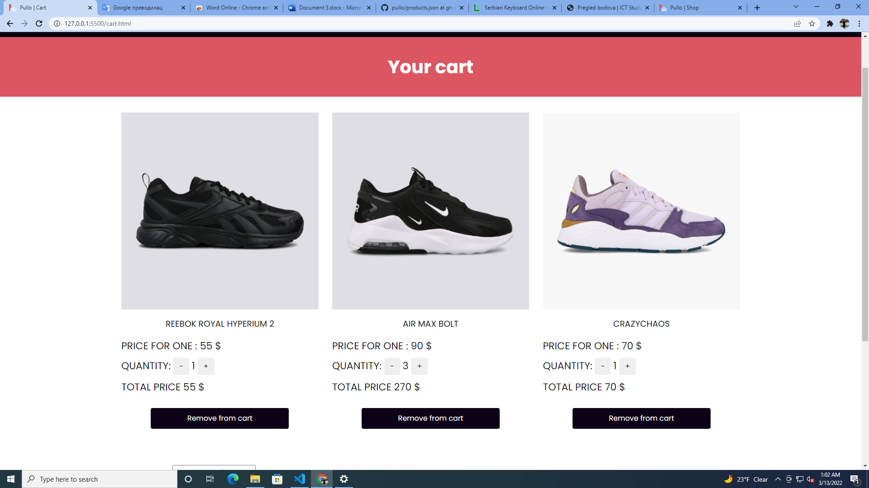

->Na ovoj stranici ispisuju se svi proizvodi koje je korisnik dodao u korpu.

->Ispisuje se količina proizvoda koja se klikom na susedne dugmice moze smanjivati ili povećavati

->Dugme Remove from cart omogucava brisanje određenog proizvoda iz korpe.

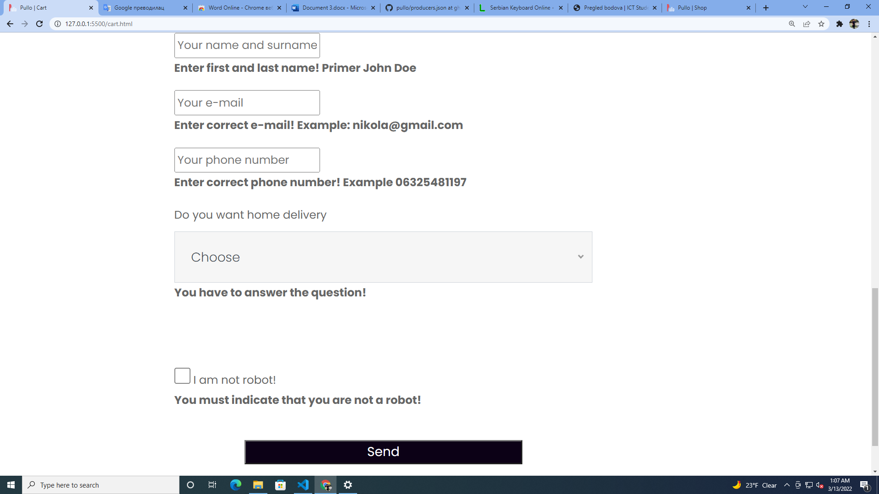->Pomocu forme se mogu naručiti proizvodi

->forma prethodno proverava ima li grešaka ,ispisuje ih, ili ukoliko ih nema daje poruku o uspešnoj kupovini:

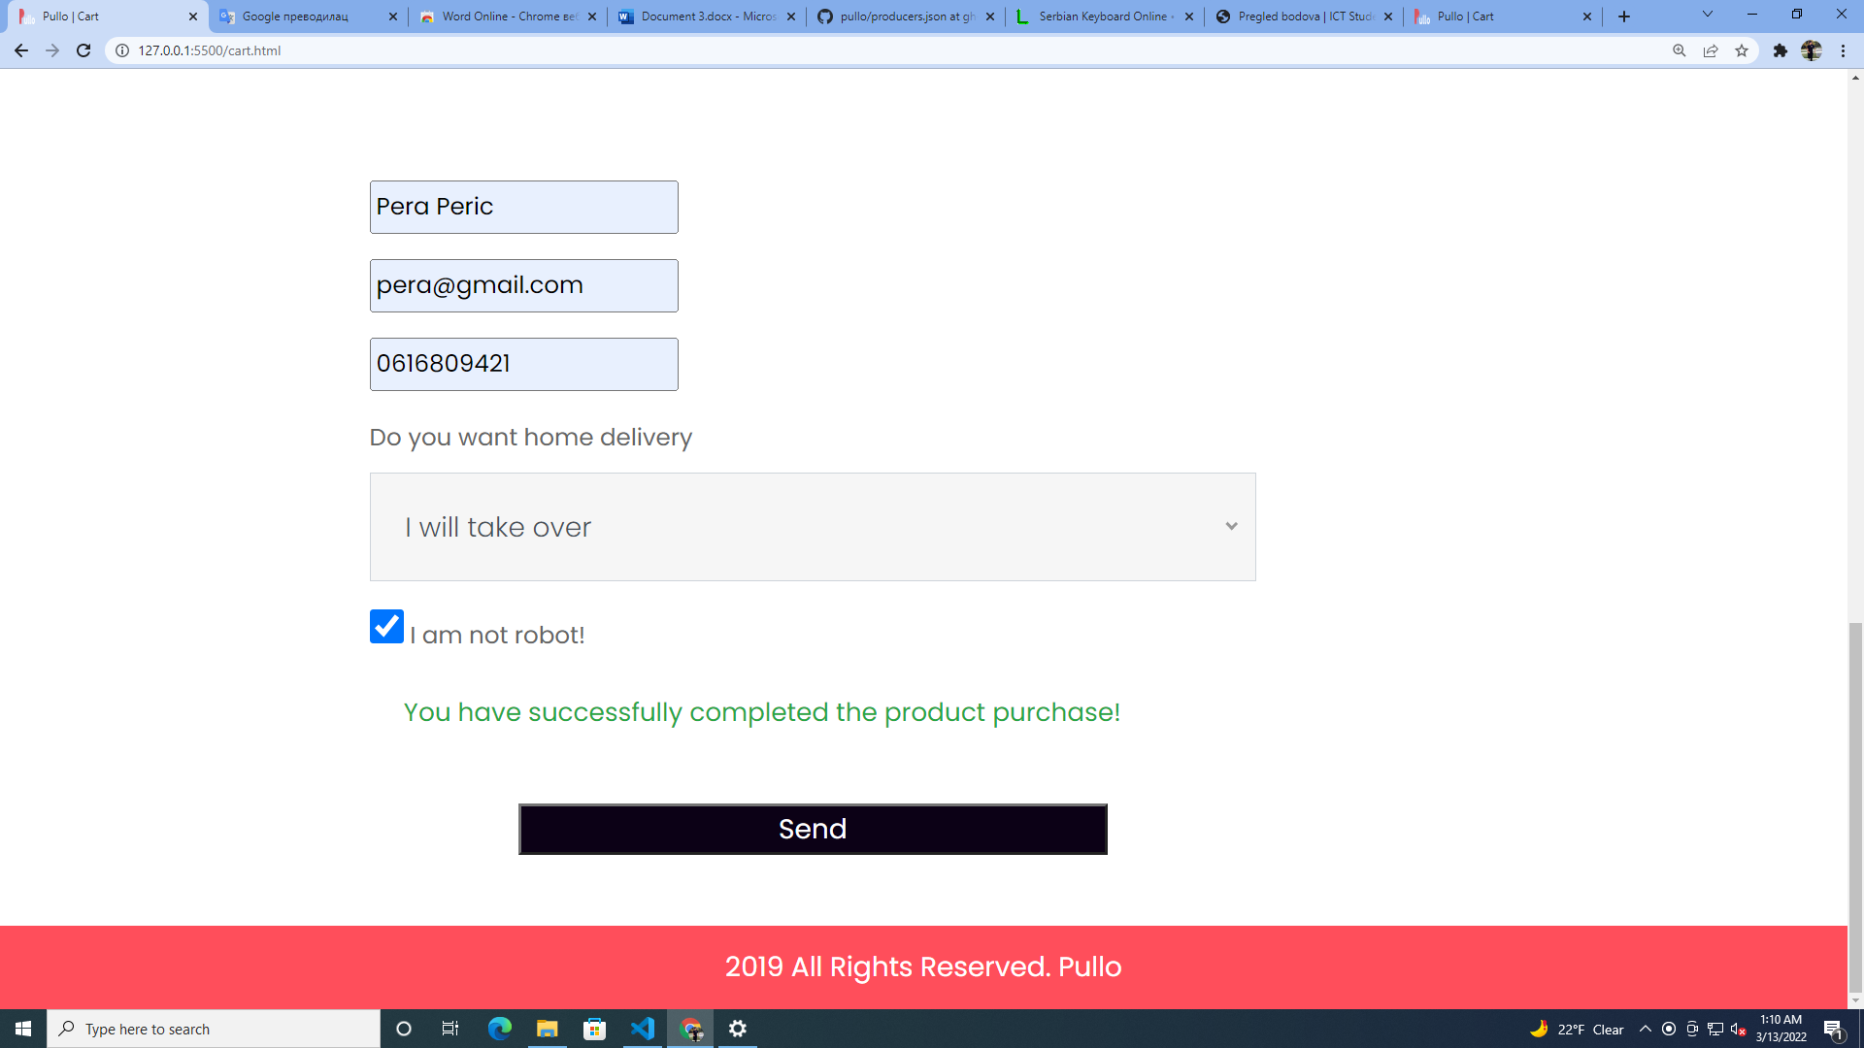

# 3.Kodovi

## 3.1 index

<!DOCTYPE html>

<html lang="en">

<head>

<!-- basic -->

<meta charset="utf-8"/>

<meta http-equiv="X-UA-Compatible" content="IE=edge"/>

<!-- mobile metas -->

<meta name="viewport" content="width=device-width, initial-scale=1"/>

<meta name="viewport" content="initial-scale=1, maximum-scale=1"/>

<!-- site metas -->

<title>Pullo | Home</title>

<meta name="keywords" content="online shop, sneakers, pullov,"/>

<meta name="description" content="Welcome to Pullo Best online shop!"/>

<meta name="author" content=" Mikola Jovanovic"/>

<!-- bootstrap css -->

<link rel="stylesheet" href="css/bootstrap.min.css"/>

<!-- style css -->

<link rel="stylesheet" href="css/style.css"/>

<!-- Responsive-->

<link rel="stylesheet" href="css/responsive.css"/>

<!-- fevicon -->

<link rel="icon" href="images/logo.png" type="png" />

<!-- Scrollbar Custom CSS -->

<link rel="stylesheet" href="css/jquery.mCustomScrollbar.min.css"/>

<!-- Tweaks for older IEs-->

<link rel="stylesheet" href="https://netdna.bootstrapcdn.com/font-awesome/4.0.3/css/font-awesome.css"/>

<!-- owl stylesheets -->

<link rel="stylesheet" href="css/owl.carousel.min.css"/>

<link rel="stylesheet" href="css/owl.theme.default.min.css"/>

<link rel="stylesheet" href="https://cdnjs.cloudflare.com/ajax/libs/fancybox/2.1.5/jquery.fancybox.min.css" media="screen"/>

<!--[if lt IE 9]>

<script src="https://oss.maxcdn.com/html5shiv/3.7.3/html5shiv.min.js"></script>

<script src="https://oss.maxcdn.com/respond/1.4.2/respond.min.js"></script><![endif]-->

</head>

<!-- body -->

<body class="main-layout">

<!-- header section start -->

<div class="header_section">

<div class="container">

<div class="row">

<div class="col-sm-3">

<div class="logo"><a href="index.html"><img src="images/logo.png"></a></div>

</div>

<div class="col-sm-9">

<nav class="navbar navbar-expand-lg navbar-light bg-light">

<button class="navbar-toggler" type="button" data-toggle="collapse" data-target="#navbarNavAltMarkup" aria-controls="navbarNavAltMarkup" aria-expanded="false" aria-label="Toggle navigation">

<span class="navbar-toggler-icon"></span>

</button>

<div class="collapse navbar-collapse" id="navbarNavAltMarkup">

<div class="navbar-nav" id="nav">

<!--<a class="nav-item nav-link" href="index.html">Home</a>

<a class="nav-item nav-link" href="collection.html">Collection</a>

<a class="nav-item nav-link" href="contact.html">Author</a>

<a class="nav-item nav-link" href="contact.html">Contact</a>-->

</div>

</div>

</nav>

</div>

</div>

</div>

<div class="banner_section">

<div class="container-fluid">

<section class="slide-wrapper">

<div class="container-fluid">

<div id="myCarousel" class="carousel slide" data-ride="carousel">

<!-- Indicators -->

<ol class="carousel-indicators">

<li data-target="#myCarousel" data-slide-to="0" class="active"></li>

<!--<li data-target="#myCarousel" data-slide-to="1"></li>

<li data-target="#myCarousel" data-slide-to="2"></li>

<li data-target="#myCarousel" data-slide-to="3"></li>-->

</ol>

<!-- Wrapper for slides -->

<div class="carousel-inner" id="carinner">

<!--<div class="carousel-item active">

<div class="row">

<div class="col-sm-2 padding_0">

<p class="mens_taital">Men Shoes</p>

<div class="page_no">0/2</div>

<p class="mens_taital_2">Men Shoes</p>

</div>

<div class="col-sm-5">

<div class="banner_taital">

<h1 class="banner_text">New Running Shoes </h1>

<h1 class="mens_text"><strong>Men's Like Plex</strong></h1>

<p class="lorem_text">ipsum dolor sit amet, consectetur adipiscing elit, sed do eiusmod tempor incididunt ut labore et dolore magna aliqua.</p>

<button class="buy_bt">Buy Now</button>

<button class="more_bt">See More</button>

</div>

</div>

<div class="col-sm-5">

<div class="shoes_img"><img src="images/running-shoes.png"></div>

</div>

</div>

</div>

<div class="carousel-item">

<div class="row">

<div class="col-sm-2 padding_0">

<p class="mens_taital">Men Shoes</p>

<div class="page_no">0/2</div>

<p class="mens_taital_2">Men Shoes</p>

</div>

<div class="col-sm-5">

<div class="banner_taital">

<h1 class="banner_text">New Running Shoes </h1>

<h1 class="mens_text"><strong>Men's Like Plex</strong></h1>

<p class="lorem_text">ipsum dolor sit amet, consectetur adipiscing elit, sed do eiusmod tempor incididunt ut labore et dolore magna aliqua.</p>

<button class="buy_bt">Buy Now</button>

<button class="more_bt">See More</button>

</div>

</div>

<div class="col-sm-5">

<div class="shoes_img"><img src="images/footballboots1.png"></div>

</div>

</div>

</div>

<div class="carousel-item">

<div class="row">

<div class="col-sm-2 padding_0">

<p class="mens_taital">Men Shoes</p>

<div class="page_no">0/2</div>

<p class="mens_taital_2">Men Shoes</p>

</div>

<div class="col-sm-5">

<div class="banner_taital">

<h1 class="banner_text">New Running Shoes </h1>

<h1 class="mens_text"><strong>Men's Like Plex</strong></h1>

<p class="lorem_text">ipsum dolor sit amet, consectetur adipiscing elit, sed do eiusmod tempor incididunt ut labore et dolore magna aliqua.</p>

<button class="buy_bt">Buy Now</button>

<button class="more_bt">See More</button>

</div>

</div>

<div class="col-sm-5">

<div class="shoes_img"><img src="images/basketboots2.png"></div>

</div>

</div>

</div>

<div class="carousel-item">

<div class="row">

<div class="col-sm-2 padding_0">

<p class="mens_taital">Men Shoes</p>

<div class="page_no">0/2</div>

<p class="mens_taital_2">Men Shoes</p>

</div>

<div class="col-sm-5">

<div class="banner_taital">

<h1 class="banner_text">New Running Shoes </h1>

<h1 class="mens_text"><strong>Men's Like Plex</strong></h1>

<p class="lorem_text">ipsum dolor sit amet, consectetur adipiscing elit, sed do eiusmod tempor incididunt ut labore et dolore magna aliqua.</p>

<button class="buy_bt">Buy Now</button>

<button class="more_bt">See More</button>

</div>

</div>

<div class="col-sm-5">

<div class="shoes_img"><img src="images/tennisboots1.png"></div>

</div>

</div>

</div>-->

</div>

</div>

</div>

</section>

</div>

</div>

</div>

<!-- header section end -->

<!-- new collection section start -->

<div class="layout_padding collection_section">

<div class="container">

<h1 class="new_text"><strong>Who we are?</strong></h1>

<p class="consectetur_text">

Pullo is an online store that has existed for 7 years. For 7 years we have been striving to provide our customers with the best services on the Internet, the best and most accurate display of the products we offer. We have many satisfied customers who have been ordering our products for many years.</p>

<div class="collection_section_2">

<div class="row">

<div class="col-md-6">

<div class="about-img">

<div class="shoes-img"><img src="images/shoes-img1.png"></div>

<p class="sport_text">Men Sports</p>

<div class="dolar_text">$<strong style="color: #f12a47;">90</strong> </div>

<div class="star_icon">

<ul>

<li><a href="#"><img src="images/star-icon.png"></a></li>

<li><a href="#"><img src="images/star-icon.png"></a></li>

<li><a href="#"><img src="images/star-icon.png"></a></li>

<li><a href="#"><img src="images/star-icon.png"></a></li>

<li><a href="#"><img src="images/star-icon.png"></a></li>

</ul>

</div>

</div>

<button class="seemore_bt"><a href="shop.html">See more</a></button>

</div>

<div class="col-md-6">

<div class="about-img2">

<div class="shoes-img2"><img src="images/shoes-img2.png"></div>

<p class="sport_text">Men Sports</p>

<div class="dolar_text">$<strong style="color: #f12a47;">90</strong> </div>

<div class="star_icon">

<ul>

<li><a href="#"><img src="images/star-icon.png"></a></li>

<li><a href="#"><img src="images/star-icon.png"></a></li>

<li><a href="#"><img src="images/star-icon.png"></a></li>

<li><a href="#"><img src="images/star-icon.png"></a></li>

<li><a href="#"><img src="images/star-icon.png"></a></li>

</ul>

</div>

</div>

</div>

</div>

</div>

</div>

</div>

<div class="collection_section">

<div class="container">

<h1 class="new_text"><strong>Instruction</strong></h1>

<p class="consectetur_text">

On our online shop, on the Shop page you can view all our products that we offer, their manufacturers and prices. Products added to cart you can order by filling out the form below. If you decide on home delivery, you can expect your product within 4 of the day.</p>

</div>

</div>

<div class="collectipn_section_3 layuot_padding">

<div class="container">

<div class="racing_shoes">

<div class="row">

<div class="col-md-8">

<div class="shoes-img3"><img src="images/shoes-img3.png"></div>

</div>

<div class="col-md-4">

<div class="sale_text"><strong>Go to the <br><span style="color: #0a0506;">CART</span><br/> FOR ORDER </div>

<button class="seemore"><a href="cart.html">See More</a></button>

</div>

</div>

</div>

</div>

</div>

<div class="collection_section layout_padding">

<div class="container">

<h1 class="new_text"><strong>New Coming Products</strong></h1>

<p class="consectetur_text">In a month, you can order the following products on our website!</p>

</div>

</div>

<!-- new collection section end -->

<!-- New Arrivals section start -->

<div class="layout_padding gallery_section">

<div class="container" >

<div class="row" id="products1Div">

<!--<div class="col-sm-4">

<div class="best_shoes">

<p class="best_text">Best Shoes </p>

<div class="shoes_icon"><img src="images/shoes-img4.png"></div>

<div class="star_text">

<div class="left_part">

<ul>

<li><a href="#"><img src="images/star-icon.png"></a></li>

<li><a href="#"><img src="images/star-icon.png"></a></li>

<li><a href="#"><img src="images/star-icon.png"></a></li>

<li><a href="#"><img src="images/star-icon.png"></a></li>

<li><a href="#"><img src="images/star-icon.png"></a></li>

</ul>

</div>

<div class="right_part">

<div class="shoes_price">$ <span style="color: #ff4e5b;">60</span></div>

</div>

</div>

</div>

</div>

<div class="col-sm-4">

<div class="best_shoes">

<p class="best_text">Best Shoes </p>

<div class="shoes_icon"><img src="images/shoes-img5.png"></div>

<div class="star_text">

<div class="left_part">

<ul>

<li><a href="#"><img src="images/star-icon.png"></a></li>

<li><a href="#"><img src="images/star-icon.png"></a></li>

<li><a href="#"><img src="images/star-icon.png"></a></li>

<li><a href="#"><img src="images/star-icon.png"></a></li>

<li><a href="#"><img src="images/star-icon.png"></a></li>

</ul>

</div>

<div class="right_part">

<div class="shoes_price">$ <span style="color: #ff4e5b;">400</span></div>

</div>

</div>

</div>

</div>

<div class="col-sm-4">

<div class="best_shoes">

<p class="best_text">Best Shoes </p>

<div class="shoes_icon"><img src="images/shoes-img6.png"></div>

<div class="star_text">

<div class="left_part">

<ul>

<li><a href="#"><img src="images/star-icon.png"></a></li>

<li><a href="#"><img src="images/star-icon.png"></a></li>

<li><a href="#"><img src="images/star-icon.png"></a></li>

<li><a href="#"><img src="images/star-icon.png"></a></li>

<li><a href="#"><img src="images/star-icon.png"></a></li>

</ul>

</div>

<div class="right_part">

<div class="shoes_price">$ <span style="color: #ff4e5b;">50</span></div>

</div>

</div>

</div>

</div>-->

</div>

<div class="row" id="products2Div">

<!--<div class="col-sm-4">

<div class="best_shoes">

<p class="best_text">Sports Shoes</p>

<div class="shoes_icon"><img src="images/shoes-img7.png"></div>

<div class="star_text">

<div class="left_part">

<ul>

<li><a href="#"><img src="images/star-icon.png"></a></li>

<li><a href="#"><img src="images/star-icon.png"></a></li>

<li><a href="#"><img src="images/star-icon.png"></a></li>

<li><a href="#"><img src="images/star-icon.png"></a></li>

<li><a href="#"><img src="images/star-icon.png"></a></li>

</ul>

</div>

<div class="right_part">

<div class="shoes_price">$ <span style="color: #ff4e5b;">70</span></div>

</div>

</div>

</div>

</div>

<div class="col-sm-4">

<div class="best_shoes">

<p class="best_text">Sports Shoes</p>

<div class="shoes_icon"><img src="images/shoes-img8.png"></div>

<div class="star_text">

<div class="left_part">

<ul>

<li><a href="#"><img src="images/star-icon.png"></a></li>

<li><a href="#"><img src="images/star-icon.png"></a></li>

<li><a href="#"><img src="images/star-icon.png"></a></li>

<li><a href="#"><img src="images/star-icon.png"></a></li>

<li><a href="#"><img src="images/star-icon.png"></a></li>

</ul>

</div>

<div class="right_part">

<div class="shoes_price">$ <span style="color: #ff4e5b;">100</span></div>

</div>

</div>

</div>

</div>

<div class="col-sm-4">

<div class="best_shoes">

<p class="best_text">Sports Shoes</p>

<div class="shoes_icon"><img src="images/shoes-img9.png"></div>

<div class="star_text">

<div class="left_part">

<ul>

<li><a href="#"><img src="images/star-icon.png"></a></li>

<li><a href="#"><img src="images/star-icon.png"></a></li>

<li><a href="#"><img src="images/star-icon.png"></a></li>

<li><a href="#"><img src="images/star-icon.png"></a></li>

<li><a href="#"><img src="images/star-icon.png"></a></li>

</ul>

</div>

<div class="right_part">

<div class="shoes_price">$ <span style="color: #ff4e5b;">90</span></div>

</div>

</div>

</div>

</div>-->

</div>

<div class="buy_now_bt">

<button class="buy_text">Buy Now</button>

</div>

</div>

</div>

</div>

<!-- New Arrivals section end -->

<!-- contact section start -->

<!-- contact section end -->

<!-- section footer start -->

<!-- section footer end -->

<div class="copyright">2019 All Rights Reserved. <a href="index.html">Pullo</a></div>

<!-- Javascript files-->

<script src="js/main.js"></script>

<script src="js/jquery.min.js"></script>

<script src="js/popper.min.js"></script>

<script src="js/bootstrap.bundle.min.js"></script>

<script src="js/jquery-3.0.0.min.js"></script>

<script src="js/plugin.js"></script>

<!-- sidebar -->

<script src="js/jquery.mCustomScrollbar.concat.min.js"></script>

<script src="js/custom.js"></script>

<!-- javascript -->

<script src="js/owl.carousel.js"></script>

<script src="https:cdnjs.cloudflare.com/ajax/libs/fancybox/2.1.5/jquery.fancybox.min.js"></script>

<script src="js/main.js"></script>

<script>

$(document).ready(function(){

$(".fancybox").fancybox({

openEffect: "none",

closeEffect: "none"

});

$('#myCarousel').carousel({

interval: false

});

//scroll slides on swipe for touch enabled devices

$("#myCarousel").on("touchstart", function(event){

var yClick = event.originalEvent.touches[0].pageY;

$(this).one("touchmove", function(event){

var yMove = event.originalEvent.touches[0].pageY;

if( Math.floor(yClick - yMove) > 1 ){

$(".carousel").carousel('next');

}

else if( Math.floor(yClick - yMove) < -1 ){

$(".carousel").carousel('prev');

}

});

$(".carousel").on("touchend", function(){

$(this).off("touchmove");

});

});

</script>

</body>

</html>

## 3.2 shop

<!DOCTYPE html>

<html lang="en">

<head>

<!-- basic -->

<meta charset="utf-8">

<meta http-equiv="X-UA-Compatible" content="IE=edge"/>

<!-- mobile metas -->

<meta name="viewport" content="width=device-width, initial-scale=1"/>

<meta name="viewport" content="initial-scale=1, maximum-scale=1"/>

<!-- site metas -->

<title>Pullo | Shop</title>

<meta name="keywords" content="shop online products nike addidas rebook puma"/>

<meta name="description" content="Welcome to our shop,you can see our products!"/>

<meta name="author" content="Nikola Jovanovic"/>

<!-- bootstrap css -->

<link rel="stylesheet" href="css/bootstrap.min.css"/>

<!-- style css -->

<link rel="stylesheet" href="css/style.css"/>

<!-- Responsive-->

<link rel="stylesheet" href="css/responsive.css"/>

<!-- fevicon -->

<link rel="icon" href="images/logo.png" type="png" /> <!-- Scrollbar Custom CSS -->

<link rel="stylesheet" href="css/jquery.mCustomScrollbar.min.css"/>

<!-- Tweaks for older IEs-->

<link rel="stylesheet" href="https://netdna.bootstrapcdn.com/font-awesome/4.0.3/css/font-awesome.css"/>

<!-- owl stylesheets -->

<link rel="stylesheet" href="css/owl.carousel.min.css"/>

<link rel="stylesheet" href="css/owl.theme.default.min.css"/>

<link rel="stylesheet" href="https://cdnjs.cloudflare.com/ajax/libs/fancybox/2.1.5/jquery.fancybox.min.css" media="screen/">

<link rel="stylesheet" href="css/style1.css"/>

<!--[if lt IE 9]>

<script src="https://oss.maxcdn.com/html5shiv/3.7.3/html5shiv.min.js"></script>

<script src="https://oss.maxcdn.com/respond/1.4.2/respond.min.js"></script><![endif]-->

</head>

<!-- body -->

<body class="main-layout">

<!-- header section start -->

<div class="header_section header_main">

<div class="container">

<div class="row">

<div class="col-sm-3">

<div class="logo"><a href="#"><img src="images/logo.png"></a></div>

</div>

<div class="col-sm-9">

<nav class="navbar navbar-expand-lg navbar-light bg-light">

<button class="navbar-toggler" type="button" data-toggle="collapse" data-target="#navbarNavAltMarkup" aria-controls="navbarNavAltMarkup" aria-expanded="false" aria-label="Toggle navigation">

<span class="navbar-toggler-icon"></span>

</button>

<div class="collapse navbar-collapse" id="navbarNavAltMarkup">

<div class="navbar-nav">

<a class="nav-item nav-link" href="index.html">Home</a>

<a class="nav-item nav-link" href="shop.html">Shop</a>

<a class="nav-item nav-link" href="cart.html">Cart</a>

<a class="nav-item nav-link" href="https://nikolajovanovic2001.github.io/portfolio1/">Author</a>

</div>

</div>

</nav>

</div>

</div>

</div>

</div>

<!-- new collection section start -->

<div class="collection_text">Shop</div>

<div class="row">

<div class="col-lg-2" id="ktgr">

</br>

<ul class="list-group">

<li class="list-group-item">

<input type="checkbox" class="text-center" id="pricediscount" value="pricediscount" name="pricediscount"/> Prices with discount

</li>

</ul>

<hr/>

</br>

<!--CATEGORIES-->

<ul class="list-group" id="producers">

</ul>

<br/>

<hr/>

</div>

<div class="col-lg-10">

<div class="container-fluid w-100 d-flex row d-flex justify-content-around align-items-center padding">

<form>

<select id="sort">

<option value="asc" >Low to high</option>

<option value="desc">High to low</option>

<option value="nameasc" selected>Name asc</option>

<option value="namedsc">Name dsc</option>

</select>

</form>

<form>

Search our products: <input type="text" id="tbPronadji" name="tbPronadji" placeholder="Search..." />

</form>

<form>

<div class="range-slider">

<input class="range-slider__range" id="range" type="range" value="130" min="0" max="130">

<span class="range-slider__value">130</span>

</div>

</form>

</div>

<div class="row d-flex justify-content-around text-center" id="products">

</div>

</div>

</div>

</div>

<!-- new collection section end -->

<!-- section footer start -->

<!--<div class="section_footer">

<div class="container">

<div class="mail_section">

<div class="row">

<div class="col-sm-6 col-lg-2">

<div><a href="#"><img src="images/footer-logo.png"></a></div>

</div>

<div class="col-sm-6 col-lg-2">

<div class="footer-logo"><img src="images/phone-icon.png"><span class="map_text">(71) 1234567890</span></div>

</div>

<div class="col-sm-6 col-lg-3">

<div class="footer-logo"><img src="images/email-icon.png"><span class="map_text">Demo@gmail.com</span></div>

</div>

<div class="col-sm-6 col-lg-3">

<div class="social_icon">

<ul>

<li><a href="#"><img src="images/fb-icon.png"></a></li>

<li><a href="#"><img src="images/twitter-icon.png"></a></li>

<li><a href="#"><img src="images/in-icon.png"></a></li>

<li><a href="#"><img src="images/google-icon.png"></a></li>

</ul>

</div>

</div>

<div class="col-sm-2"></div>

</div>

</div>

<div class="footer_section_2">

<div class="row">

<div class="col-sm-4 col-lg-2">

<p class="dummy_text"> ipsum dolor sit amet, consectetur ipsum dolor sit amet, consectetur ipsum dolor sit amet,</p>

</div>

<div class="col-sm-4 col-lg-2">

<h2 class="shop_text">Address </h2>

<div class="image-icon"><img src="images/map-icon.png"><span class="pet_text">No 40 Baria Sreet 15/2 NewYork City, NY, United States.</span></div>

</div>

<div class="col-sm-4 col-md-6 col-lg-3">

<h2 class="shop_text">Our Company </h2>

<div class="delivery_text">

<ul>

<li>Delivery</li>

<li>Legal Notice</li>

<li>About us</li>

<li>Secure payment</li>

<li>Contact us</li>

</ul>

</div>

</div>

<div class="col-sm-6 col-lg-3">

<h2 class="adderess_text">Products</h2>

<div class="delivery_text">

<ul>

<li>Prices drop</li>

<li>New products</li>

<li>Best sales</li>

<li>Contact us</li>

<li>Sitemap</li>

</ul>

</div>

</div>

<div class="col-sm-6 col-lg-2">

<h2 class="adderess_text">Newsletter</h2>

<div class="form-group">

<input type="text" class="enter_email" placeholder="Enter Your email" name="Name">

</div>

<button class="subscribr_bt">Subscribe</button>

</div>

</div>

</div>

</div>

</div>

</div>-->

<!-- section footer end -->

<div class="copyright">2019 All Rights Reserved. <a href="index.html">Pullo</a></div>

<div class="modal fade" id="exampleModalCenter" tabindex="-1" role="dialog" aria-labelledby="exampleModalCenterTitle" aria-hidden="true">

<div class="modal-dialog modal-dialog-centered" role="document">

<div class="modal-content">

<div class="modal-header">

<h5 class="modal-title" id="exampleModalLongTitle">You added product!</h5>

<button type="button" class="close" data-dismiss="modal" aria-label="Close">

<span aria-hidden="true">&times;</span>

</button>

</div>

<div class="modal-body">

You have added a product to the cart! To view the contents of the basket, click the link:<a href="shoes.html">your cart</a>, or the link in menu.

</div>

<div class="modal-footer">

<button type="button" class="btn btn-secondary" data-dismiss="modal">Close</button>

</div>

</div>

</div>

</div>

<!-- Javascript files-->

<script src="js/jquery.min.js"></script>

<script src="js/popper.min.js"></script>

<script src="js/bootstrap.bundle.min.js"></script>

<script src="js/jquery-3.0.0.min.js"></script>

<script src="js/plugin.js"></script>

<!-- sidebar -->

<script src="js/jquery.mCustomScrollbar.concat.min.js"></script>

<script src="js/custom.js"></script>

<!-- javascript -->

<script src="js/owl.carousel.js"></script>

<script src="https:cdnjs.cloudflare.com/ajax/libs/fancybox/2.1.5/jquery.fancybox.min.js"></script>

<script src="js/main2.js"></script>

<script src="jquery-3.5.1.min.js"></script>

<script>

$(document).ready(function(){

$(".fancybox").fancybox({

openEffect: "none",

closeEffect: "none"

});

$('#myCarousel').carousel({

interval: false

});

//scroll slides on swipe for touch enabled devices

$("#myCarousel").on("touchstart", function(event){

var yClick = event.originalEvent.touches[0].pageY;

$(this).one("touchmove", function(event){

var yMove = event.originalEvent.touches[0].pageY;

if( Math.floor(yClick - yMove) > 1 ){

$(".carousel").carousel('next');

}

else if( Math.floor(yClick - yMove) < -1 ){

$(".carousel").carousel('prev');

}

});

$(".carousel").on("touchend", function(){

$(this).off("touchmove");

});

});}

</script>

</body>

</html>

## 3.3 cart

<!DOCTYPE html>

<html lang="en">

<head>

<!-- basic -->

<meta charset="utf-8">

<meta http-equiv="X-UA-Compatible" content="IE=edge"/>

<!-- mobile metas -->

<meta name="viewport" content="width=device-width, initial-scale=1"/>

<meta name="viewport" content="initial-scale=1, maximum-scale=1"/>

<!-- site metas -->

<title>Pullo | Cart</title>

<meta name="keywords" content="cart products order form"/>

<meta name="description" content="Welcome to your cart!"/>

<meta name="author" content="Nikola Jovanovic"/>

<!-- bootstrap css -->

<link rel="stylesheet" href="css/bootstrap.min.css"/>

<!-- style css -->

<link rel="stylesheet" href="css/style.css"/>

<!-- Responsive-->

<link rel="stylesheet" href="css/responsive.css"/>

<!-- fevicon -->

<link rel="icon" href="images/logo.png" type="png" />

<!-- Scrollbar Custom CSS -->

<link rel="stylesheet" href="css/jquery.mCustomScrollbar.min.css"/>

<!-- Tweaks for older IEs-->

<link rel="stylesheet" href="https://netdna.bootstrapcdn.com/font-awesome/4.0.3/css/font-awesome.css"/>

<!-- owl stylesheets -->

<link rel="stylesheet" href="css/owl.carousel.min.css"/>

<link rel="stylesheet" href="css/owl.theme.default.min.css"/>

<script src="https://kit.fontawesome.com/d34a742f3a.js" crossorigin="anonymous"></script>

<link rel="stylesheet" href="https://cdnjs.cloudflare.com/ajax/libs/fancybox/2.1.5/jquery.fancybox.min.css" media="screen"/>

<link href="https://unpkg.com/aos@2.3.1/dist/aos.css" rel="stylesheet" />

<link rel="preconnect" href="https://fonts.gstatic.com"/>

<link rel="preconnect" href="https://fonts.gstatic.com"/>

<link rel="preconnect" href="https://fonts.gstatic.com"/>

<link href="https://fonts.googleapis.com/css2?family=Merriweather:wght@400;700&family=Roboto+Slab:wght@300&display=swap" rel="stylesheet"/>

<link href="https://fonts.googleapis.com/css2?family=Roboto+Slab:wght@300&display=swap" rel="stylesheet" />

<link href="https://fonts.googcss/font-awesome.min,css" rel="stylesheet"/>

<script src="https://kit.fontawesome.com/d34a742f3a.js" crossorigin="anonymous"></script>

<link href="https://fonts.googleapis.com/css2?family=Pacifico&display=swap" rel="stylesheet"/>

<link rel="stylesheet" href="https://cdnjs.cloudflare.com/ajax/libs/font-awesome/4.7.0/css/font-awesome.min.css"/>

<link href="https://unpkg.com/aos@2.3.1/dist/aos.css" rel="stylesheet" />

<link rel="stylesheet" href="https://cdnjs.cloudflare.com/ajax/libs/owl-carousel/1.3.3/owl.carousel.min.css"/>

<link rel="stylesheet" href="https://cdnjs.cloudflare.com/ajax/libs/owl-carousel/1.3.3/owl.theme.min.css"/>

<link rel="preconnect" href="https://fonts.gstatic.com" crossorigin/>

<link href="https://fonts.googleapis.com/css2?family=Merriweather:wght@300&display=swap" rel="stylesheet"/>

<!--[if lt IE 9]>

<script src="https://oss.maxcdn.com/html5shiv/3.7.3/html5shiv.min.js"></script>

<script src="https://oss.maxcdn.com/respond/1.4.2/respond.min.js"></script><![endif]-->

</head>

<!-- body -->

<body class="main-layout">

<!-- header section start -->

<div class="header_section header_main">

<div class="container">

<div class="row">

<div class="col-sm-3">

<div class="logo"><a href="#"><img src="images/logo.png"></a></div>

</div>

<div class="col-sm-9">

<nav class="navbar navbar-expand-lg navbar-light bg-light">

<button class="navbar-toggler" type="button" data-toggle="collapse" data-target="#navbarNavAltMarkup" aria-controls="navbarNavAltMarkup" aria-expanded="false" aria-label="Toggle navigation">

<span class="navbar-toggler-icon"></span>

</button>

<div class="collapse navbar-collapse" id="navbarNavAltMarkup">

<div class="navbar-nav">

<a class="nav-item nav-link" href="index.html">Home</a>

<a class="nav-item nav-link" href="shop.html">Shop</a>

<a class="nav-item nav-link" href="cart.html">Cart</a>

<a class="nav-item nav-link" href="https://nikolajovanovic2001.github.io/portfolio1/">Author</a>

</div>

</div>

</nav>

</div>

</div>

</div>

</div>

<!-- New Arrivals section start -->

<div class="collection_text">Your cart</div>

<div class=" d-flex justify-content-center w-100 content padding" >

<div class="row col-lg-9 col-md-9 col-sm-12 d-flex justify-content-around padding" id="content">

</div>

</div>

<div class="d-flex justify-content-center w-100 content ">

<form class="forma">

<div class="field">

<input type="text" name="ime" placeholder="Your name and surname" id="polje1" />

<div class="greska"></div>

</div>

<div class="field">

<input type="email" name="e-mail" placeholder="Your e-mail" id="polje2" />

<div class="greska"></div>

</div>

<div class="field">

<input type="text" placeholder="Your phone number" id="polje3" name="telefon" />

<div class="greska"></div>

</div>

<div class="field">

<label for="exampleFormControlSelect1">Do you want home delivery</label>

<select class="form-control" id="exampleFormControlSelect1" name="Godine iskustva ">

<option>Choose</option>

<option>I will take over</option>

<option>I want delivery</option>

</select>

<div class="greska"></div>

</div><br/>

<div class="field">

<br/><input type="checkbox" id="nisamrobot" name="nisamrobot" value="nisamrobot"/> I am not robot!

<div class="greska"></div>

</div>

<div class="ukupno">

</div>

<div class="field poruka">

</div>

<div class="field btn duzina">

<div class="btn-layer"></div>

<input type="button" class="button1" value="Send"/>

</div>

</form>

</div>

<!-- New Arrivals section end -->

<!-- section footer start -->

<!-- section footer end -->

<div class="copyright">2019 All Rights Reserved. <a href="index.html">Pullo</a></div>

<!-- Small modal -->

<!-- Javascript files-->

<script src="js/jquery.min.js"></script>

<script src="js/popper.min.js"></script>

<script src="js/bootstrap.bundle.min.js"></script>

<script src="js/jquery-3.0.0.min.js"></script>

<script src="js/plugin.js"></script>

<!-- sidebar -->

<script src="js/jquery.mCustomScrollbar.concat.min.js"></script>

<script src="js/custom.js"></script>

<!-- javascript -->

<script src="js/owl.carousel.js"></script>

<script src="https:cdnjs.cloudflare.com/ajax/libs/fancybox/2.1.5/jquery.fancybox.min.js"></script>

<script src="js/main2.js"></script>

<script>

$(document).ready(function(){

$(".fancybox").fancybox({

openEffect: "none",

closeEffect: "none"

});

$('#myCarousel').carousel({

interval: false

});

//scroll slides on swipe for touch enabled devices

$("#myCarousel").on("touchstart", function(event){

var yClick = event.originalEvent.touches[0].pageY;

$(this).one("touchmove", function(event){

var yMove = event.originalEvent.touches[0].pageY;

if( Math.floor(yClick - yMove) > 1 ){

$(".carousel").carousel('next');

}

else if( Math.floor(yClick - yMove) < -1 ){

$(".carousel").carousel('prev');

}

});

$(".carousel").on("touchend", function(){

$(this).off("touchmove");

});

});

</script>

</body>

</html>

## 3.4 css

/*--------------------------------------------------------------------- File Name: style.css ---------------------------------------------------------------------*/

/*--------------------------------------------------------------------- import Fonts ---------------------------------------------------------------------*/

@import url('https://fonts.googleapis.com/css?family=Rajdhani:300,400,500,600,700');

@import url('https://fonts.googleapis.com/css?family=Poppins:100,100i,200,200i,300,300i,400,400i,500,500i,600,600i,700,700i,800,800i,900,900i');

/*****---------------------------------------- 1) font-family: 'Rajdhani', sans-serif;

2) font-family: 'Poppins', sans-serif;

----------------------------------------*****/

/*--------------------------------------------------------------------- import Files ---------------------------------------------------------------------*/

@import url(animate.min.css);

@import url(normalize.css);

@import url(meanmenu.css);

@import url(owl.carousel.min.css);

@import url(slick.css);

@import url(jquery-ui.css);

@import url(nice-select.css);

/*--------------------------------------------------------------------- skeleton ---------------------------------------------------------------------*/

* {

box-sizing: border-box !important;

transition: ease all 0.5s;

}

html {

scroll-behavior: smooth;

}

body {

color: #666666;

font-size: 14px;

font-family: Poppins;

line-height: 1.80857;

font-weight: normal;

overflow-x: hidden;

}

a {

color: #1f1f1f;

text-decoration: none !important;

outline: none !important;

-webkit-transition: all .3s ease-in-out;

-moz-transition: all .3s ease-in-out;

-ms-transition: all .3s ease-in-out;

-o-transition: all .3s ease-in-out;

transition: all .3s ease-in-out;

}

h1,

h2,

h3,

h4,

h5,

h6 {

letter-spacing: 0;

font-weight: normal;

position: relative;

padding: 0 0 10px 0;

font-weight: normal;

line-height: normal;

color: #111111;

margin: 0

}

h1 {

font-size: 24px

}

h2 {

font-size: 22px

}

h3 {

font-size: 18px

}

h4 {

font-size: 16px

}

h5 {

font-size: 14px

}

h6 {

font-size: 13px

}

*,

*::after,

*::before {

-webkit-box-sizing: border-box;

-moz-box-sizing: border-box;

box-sizing: border-box;

}

h1 a,

h2 a,

h3 a,

h4 a,

h5 a,

h6 a {

color: #212121;

text-decoration: none!important;

opacity: 1

}

button:focus {

outline: none;

}

ul,

li,

ol {

margin: 0px;

padding: 0px;

list-style: none;

}

p {

margin: 20px;

font-weight: 300;

font-size: 15px;

line-height: 24px;

}

a {

color: #222222;

text-decoration: none;

outline: none !important;

}

a,

.btn {

text-decoration: none !important;

outline: none !important;

-webkit-transition: all .3s ease-in-out;

-moz-transition: all .3s ease-in-out;

-ms-transition: all .3s ease-in-out;

-o-transition: all .3s ease-in-out;

transition: all .3s ease-in-out;

}

img {

max-width: 100%;

height: auto;

}

:focus {

outline: 0;

}

.paddind_bottom_0 {

padding-bottom: 0 !important;

}

.btn-custom {

margin-top: 20px;

background-color: transparent !important;

border: 2px solid #ddd;

padding: 12px 40px;

font-size: 16px;

}

.lead {

font-size: 18px;

line-height: 30px;

color: #767676;

margin: 0;

padding: 0;

}

.form-control:focus {

border-color: #ffffff !important;

box-shadow: 0 0 0 .2rem rgba(255, 255, 255, .25);

}

.navbar-form input {

border: none !important;

}

.badge {

font-weight: 500;

}

blockquote {

margin: 20px 0 20px;

padding: 30px;

}

button {

border: 0;

margin: 0;

padding: 0;

cursor: pointer;

}

.full {

float: left;

width: 100%;

}

.layout_padding {

padding-top: 90px;

padding-bottom: 90px;

}

.header_section{

width: 100%;

float: left;

background-image: url(../images/banner.png);

height: auto;

padding: 20px 0px;

background-size: 100%;

background-repeat: no-repeat;

}

.padding_0{ width: 100%; float: left; }

.mens_taital{ width: 100%; float: left; color: #908d92; font-size: 14pt; }

.mens_taital_2 {

width: 100%;

float: left;

color: #908d92;

font-size: 14pt;

margin-top: 150px;

}

.page_no {

width: 28%;

/* margin: 0 auto; */

text-align: center;

color: #ffffff;

border: 2px solid #8d8791;

border-radius: 30px;

margin-top: 150px;

padding-bottom: 10px;

display: inline-block;

padding-top: 12px;

margin-left: 30px;

}

.bg-light {

background-color: transparent !important;

}

.navbar-light .navbar-nav .nav-link {

color: #fff;

font-size: 16pt;

}

.navbar-light .navbar-nav .nav-link:focus, .navbar-light .navbar-nav .nav-link:hover {

color: #db5660;

}

.navbar-expand-lg .navbar-nav .nav-link {

padding-right: 0.9rem;

padding-left: 1.6rem;

}

.last{ padding-left: 30px !important; }

.banner_text{

width: 100%;

float: left;

font-size: 30pt;

color: #db5660;

}

.mens_text{

width: 100%;

float: left;

font-size: 39pt;

color: #fdfcfc;

line-height: 40px;

}

.lorem_text{

width: 100%;

float: left;

font-size: 13pt;

color: #fefefe;

margin-left: 0px;

}

.buy_bt{

width: 32%;

height: 50px;

color: #ffffff;

background-color: #ff4e5b;

color: #ffffff;

font-size: 16pt;

}

.more_bt{

width: 32%;

height: 50px;

color: #ffffff;

background-color: #ffffff;

color: #ff4e5b;

font-size: 16pt;

margin-left: 25px;

}

.banner_taital{

width: 100%;

float: left;

margin-top: 85px;

}

body{

width:100%;

height:100%;

}

.carousel-inner,.carousel,.carousel-item,.container,.fill {

height:100%;

width:100%;

background-position:center center;

background-size:cover;

}

.slide-wrapper{display:inline;}

.slide-wrapper .container{padding:0;}

/*------------------------------ vertical bootstrap slider----------------------------*/

.carousel-inner> .carousel-item.carousel-item-next ,

.carousel-inner > .carousel-item.active.carousel-item-right{

transform: translate3d(0, 100%, 0); -webkit-transform: translate3d(0, 100%, 0); -ms-transform: translate3d(0, 100%, 0); -moz-transform: translate3d(0, 100%, 0); -o-transform: translate3d(0, 100%, 0); top: 0;

}

.carousel-inner > .carousel-item.carousel-item-prev ,

.carousel-inner > .carousel-item.active.carousel-item-left{

transform: translate3d(0,-100%, 0); -webkit-transform: translate3d(0,-100%, 0); -moz-transform: translate3d(0,-100%, 0);-ms-transform: translate3d(0,-100%, 0); -o-transform: translate3d(0,-100%, 0); top: 0;

}

.carousel-inner > .carousel-item.next.carousel-item-left ,

.carousel-inner > .carousel-item.carousel-item-prev.carousel-item-right ,

.carousel-inner > .carousel-item.active{

transform:translate3d(0,0,0); -webkit-transform:translate3d(0,0,0);-ms-transform:translate3d(0,0,0);; -moz-transform:translate3d(0,0,0); -o-transform:translate3d(0,0,0); top:0;

}

/*------------------------------- vertical carousel indicators ------------------------------*/

.carousel-indicators{

position:absolute;

top:0;

bottom:0;

margin:auto;

height:20px;

right:-84px;

left:auto;

width:auto;

-webkit-transform: rotate(90deg);

-moz-transform: rotate(90deg);

-ms-transform: rotate(90deg);

-o-transform: rotate(90deg);

transform: rotate(90deg);

}

.carousel-indicators li{

display:block; margin-bottom:5px; border:1px solid #00a199;

margin-bottom: 5px;}

.carousel-indicators li.active{

margin-bottom:5px; background:#00a199;

}

.collection_section{ width: 100%; float: left; padding-bottom: 0px; }

.new_text{

width: 100%;

float: left;

font-size: 24pt;

color: #0c0116;

}

.consectetur_text{

width: 100%;

float: left;

font-size: 14pt;

color: #0c0116;

font-weight: 400;

margin-left: 0px;

padding-bottom: 30px;

}

.collection_section_2{

width: 100%;

float: left;

}

.about-img {

width: 100%;

float: left;

background-color: #ffffff;

height: auto;

margin-left: 64px;

box-shadow: 0px 0px 10px 0px;

position: relative;

z-index: 1;

}

.new_bt{

width: 18%;

float: left;

background-color: #000;

font-size: 14pt;

text-align: center;

color: #ffffff;

height: 50px;

margin-left: -60px;

}

.shoes-img{

width: 100%;

float: left;

text-align: center;

padding-top: 40px;

padding-bottom: 40px;

margin: 0px;

}

.sport_text {

width: 24%;

text-align: center;

padding-top: 30px;

font-size: 16pt;

color: #0c0116;

border-bottom: 1px solid#000;

margin: 0 auto;

}

.dolar_text{

width: 100%;

float: left;

text-align:center;

color: #000;

font-size: 20pt;

}

.star_icon{ width: 25%; margin: 0 auto; text-align: center; }

.star_icon ul{ margin: 0px; padding: 0px;}

.star_icon li{ float:left; padding-right:10px; padding-bottom: 25px;}

.about-img2{

width: 100%;

float: left;

background-image: url(../images/about-img2.png);

height: auto;

box-shadow: 0px 0px 10px 0px;

margin-left: -50px;

margin-top: 74px;

}

.shoes_img{ width: 100%; float: left; padding-top: 30px; }

.shoes-img2{

width: 100%;

float: left;

text-align: center;

padding-top: 100px;

padding-bottom: 40px;

margin: 0px

}

.seemore_bt{

width: 32%;

height: 50px;

color: #ffffff;

background-color: #ff4e5b;

color: #ffffff;

font-size: 16pt;

margin-top: 35px;

margin-bottom: 90px;

}

.collectipn_section_3{ width: 100%; float: left; padding-top: 0px;}

.racing_shoes {

width: 100%;

float: left;

background-color: #eae7e7;

height: auto;

padding-top: 70px;

background-size: 100%;

padding-bottom: 70px;

}

.shoes-img3{ width: 100%; float: left; text-align: center; }

.collection_text{

width: 100%;

float: left;

color: #ffffff;

text-align: center;

font-weight: bold;

font-size: 40px;

background-color: #db5660;

padding: 30px 0px;

}

.sale_text{

width: 100%;

float: left;

font-size: 45pt;

color: #ed2540;

line-height: 75px;

}

.number_text{

width: 100%;

float: left;

font-size: 45pt;

color: #ed2540;

line-height: 75px;

}

hr{color: #ed2540;}

.seemore{

width: 50%;

height: 50px;

color: #ffffff;

background-color: #ff4e5b;

color: #ffffff;

font-size: 16pt;

margin-top: 35px;

}

.gallery_section{

width: 100%;

float: left;

background-color: #ff4e5b;

height: auto;

}

.best_shoes {

width: 100%;

float: left;

background-color: #ffffff;

height: auto;

padding: 20px 20px 20px 0px;

margin-top: 15px;

margin-bottom: 15px;

}

.best_text{

width: 100%;

float: left;

font-size: 14pt;

color: #000;

text-align: center;

margin-left: 0px;

}

.shoes_icon{

width: 100%;

float: left;

text-align: center;

min-height: 220px;

}

.star_text{

width: 100%;

float: left;

}

.left_part {

width: 60%;

float: left;

padding-left: 15px;

padding-top: 15px;

}

.left_part ul{ margin: 0px; padding: 0px; }

.left_part li{ float: left; padding-left: 10px; }

.right_part{ width: 40%; float: left; }

.shoes_price{

width: 100%;

float: left;

font-size: 22pt;

color: #0f0d10;

text-align: right;

}

.buy_now_bt{

width: 50%;

margin: 0 auto;

text-align: center;

}

.buy_text{

width: 32%;

height: 50px;

color: #ffffff;

background-color: #131111;

color: #ffffff;

font-size: 16pt;

margin-top: 35px;

}

.contact_section{

width: 100%;

float: left;

}

.email_box {

width: 85%;

float: right;

background-color: #14120e;

height: auto;

padding: 20px 20px;

opacity: 0.80;

}

.form-group {

margin-bottom: 2rem;

}

.email-bt {

border: 1px solid #000;

color: #000000;

width: 100%;

height: 55px;

font-size: 22px;

padding: 20px;

}

.massage-bt {

border: 1px solid #000;

color: #000000;

width: 100%;

height: 200px;

font-size: 22px;

padding: 70px 20px 10px 20px;

}

.send_btn {

width: 100%;

margin: 0 auto;

text-align: center;

}

.main_bt {

background: #ff4e5b;

border: none;

width: 170px;

height: 58px;

font-size: 26px;

color: #ffffff;

}

.ram{

width: 100%;

float: left;

}

a:hover {

color: #fff;

}

.shop_banner{

width: 100%;

float: left;

background-image: url(../images/shop-banner.png);

height: auto;

padding: 70px;

}

.our_shop {

width: 100%;

float: left;

padding-top: 205px;

padding-bottom: 205px;

}

.out_shop_bt {

width: 40%;

margin: 0 auto;

background-color: #ffffff;

color: #131111;

text-align: center;

font-size: 20pt;

display: block;

}

.section_footer {

width: 100%;

float: left;

background-color: #272222;

height: auto;

padding-top: 30px;

padding-bottom: 30px;

}

.mail_section {

width: 100%;

float: left;

}

.footer-logo {

float: left;

font-size: 12pt;

color: #fdfefe;

}

.mail_section li {

float: left;

font-size: 12pt;

color: #fdfefe;

padding-right: 35px;

}

.footer_section_2 {

width: 100%;

float: left;

padding-top: 20px;

}

.shop_text {

width: 100%;

float: left;

font-size: 28px;

color: #ebebeb;

}

.dummy_text {

width: 100%;

float: left;

font-size: 12pt;

color: #ffffff;

margin-left: 0px;

margin-top: 55px;

line-height: 25px;

}

.image-icon {

width: 100%;

float: left;

padding-top: 6px;

}

.pet_text {

font-size: 12pt;

color: #ffffff;

padding-left: 16px;

display: flex;

top: -26px;

position: relative;

padding-left: 20px;

}

.adderess_text {

width: 100%;

float: left;

font-size: 28px;

color: #ebebeb;

}

.copyright {

width: 100%;

float: left;

font-size: 12pt;

color: #ffffff;

text-align: center;

padding: 10px 0px;

background-color: #ff4e5b;

font-family: Poppins;

}

.copyright a{ color: #ffffff; }

.copyright a:hover{ color: #000; }

.map_text {

padding-left: 15px;

}

.delivery_text{

width: 100%;

float: left;

font-size: 17px;

color: #ffffff;

}

.enter_email{

border: 1px solid #000;

color: #000000;

width: 100%;

height: 44px;

font-size: 14px;

padding: 20px;

}

.subscribr_bt {

width: 80%;

float: right;

background-color: #ff4e5b;

font-size: 13pt;

height: 50px;

color: #ffffff;

}

.about_main {

width: 100%;

float: left;

padding-bottom: 30px;

}

.header_main {

width: 100%;

height: auto;

background: #0c0116;

}

.card img {

height: 200px;

width: auto !important;

display: block;

margin: 0 auto;

}

.card img.img-fluid {

height: 500px;

}

body > .container {

min-height: 100vh;

}

.carousel-item{

height: 80vh;

overflow-y: hidden;

overflow-x: hidden;

}

.carousel-item img{

width: 100%;

transform: translateY(-55px);/*175*/

}

hr{color:#0c0116;background-color: #0c0116; height:3px;}

.range-slider__range{color:#ed2540 !important;}

.divs img{width: 100% !important;}

.best_shoes{padding: 0;}

.nice-select{width:100%;}

#sort{display:none;}

#ktgr ul li{text-align: center; border:none;}

.padding{padding-top:10px; padding-bottom: 10px;}

.add-to-cart{background-color: #0c0116; color:white; width: 70%; font-size:16px;}

.remove{background-color: #0c0116; color:white; width: 70%; font-size:16px;}

.remove-one{background-color: #0c0116; color:white; width: 70%; font-size:16px;}

.margins{margin-top:20px;margin-bottom: 10px;}

.imgx{width: 50px; height: 50px;}

table{width: 95%;}

table th{border:none;background-color: #0c0116;color:white;text-align:center}

table tr{border-bottom: 1px solid #0c0116;}

table td{text-align: center;}

.imgprod{height:100px; width:60%;}

.content{background-color: white; background-size: cover;background-attachment: cover; background-position: center;}

#content{margin-bottom: 20px;background-color: rgba(255, 255, 255, 0); background-size: cover;background-attachment: cover; background-position: center;}

.copyright{margin-top: 20px;}

table tr:hover{background-color: #F3F1F5;}

@media screen and (max-width: 610px)

{

.field{width:100%;}

#polje1,#polje2,#polje3{width: 100%;}

}

.forma{width:60%;}

.field{width: 80%; margin-top: 15px;margin-bottom: 15px;}

.form select{width:20%;}

.button1{background-color: #0c0116; color:white; width: 70%; font-size:16px;}

#nisamrobot{width:20px;height: 20px;}

#exampleFormControlSelect1{display: none;}

.minus, .plus{color:#0c0116;}

## 3.5 main.js

// ajax callback function

function ajaxCallBack(url, result){

$.ajax({

url: url,

method: "get",

dataType: "json",

success: result,

error: function(xhr){console.log(xhr);}

});

}

// funkcija za skladistenje podataka u local storage

function setItemToLocalStorage(name, data){

localStorage.setItem(name, JSON.stringify(data));

}

// funkcija za iscitavanje podataka iz local storage-a

function getItemFromLocalStorage(name){

return JSON.parse(localStorage.getItem(name));

}

window.onload = function(){

let url = window.location.pathname;

if(url == "/" || url == "/index.html"){

// dohvatanje podataka iz fajla products.json

ajaxCallBack("assets/data/products.json", function(result){

// console.log(result)

setItemToLocalStorage("allProducts", result);

printProducts(result);

})

// funkcija koja ispisuje broj proizvoda u korpi

printCartLength();

}

if(url == "/checkout.html"){

let productsFromCart = getItemFromLocalStorage("cart");

if(productsFromCart == null){

showEmptyCart();

}

else{

showCart();

}

}

}

// funkcija za ispisivanje proizvoda na pocetnoj stranici

function printProducts(arrProducts){

let html = "";

let divProducts = $("#div-products");

if(arrProducts.length == 0){

html = `<div class="col-12">

<p class="alert alert-danger">Trenutno nema proizvoda.</p>

</div>`

}

else{

for(let objProduct of arrProducts){

html += printSingleProduct(objProduct);

}

}

$(divProducts).html(html);

$('.add-to-cart').click(addToCart);

}

// funkcija za stampanje pojedinacnog proizvoda

function printSingleProduct(product){

return `

<div class="col-md-3 product-men mt-5">

<div class="men-pro-item simpleCart_shelfItem">

<div class="men-thumb-item text-center">

<img src="assets/images/${product.picture.src}" style='height:200px' class='img-fluid' alt="${product.picture.alt}" />

<div class="men-cart-pro">

<div class="inner-men-cart-pro">

<a href="#" class="link-product-add-cart">Quick View</a>

</div>

</div>

</div>

<div class="item-info-product text-center border-top mt-4">

<h4 class="pt-1">

<a href="#">${product.name}</a>

</h4>

<div class="info-product-price my-2">

<span class="item_price">$${product.price.new}</span>

<del>$${product.price.old}</del>

</div>

<div class="snipcart-details top_brand_home_details item_add single-item hvr-outline-out">

<input type="button" data-id=${product.id} value="Add to cart" class="button btn add-to-cart" />

</div>

</div>

</div>

</div>

`;

}

// funkcija za dodavanje proizvoda u korpu

function addToCart(){

let idProduct = $(this).data("id");

// console.log(idProduct)

let productsFromCart = getItemFromLocalStorage("cart");

// console.log(productsFromCart)

if(productsFromCart){

// kod kada korpa nije prazna

if(productIsAlreadyInCart()){

// kod ako dodajemo proizvod koji vec postoji u korpi

updateQty();

}

else{

// kod ako dodajemo proizvod koji NIJE u korpi

addNewProductToCart();

printCartLength()

}

}

else{

// kod kada je korpa prazna

addFirstProductToCart();

printCartLength()

}

// funkcija koja dodaje prvi proizvod u korpu

function addFirstProductToCart(){

let products = [];

products[0] = {

id: idProduct,

qty: 1

}

setItemToLocalStorage("cart", products);

}

// funkcija koja proverava da li proizvod vec postoji u korpi

function productIsAlreadyInCart(){

return productsFromCart.filter(p => p.id == idProduct).length;

}

// funkcija koja azurira kolicinu postojeceg proizvoda iz korpe

function updateQty(){

let productsFromLS = getItemFromLocalStorage("cart");

for(let product of productsFromLS){

if(product.id == idProduct){

product.qty++;

break;

}

}

setItemToLocalStorage("cart", productsFromLS);

}

// funkcija koja dodaje proizvod u punu korpu, a taj proizvod nije u njoj

function addNewProductToCart(){

let productsFromLS = getItemFromLocalStorage("cart");

productsFromLS.push({

id: idProduct,

qty: 1

});

setItemToLocalStorage("cart", productsFromLS);

}

}

// funkcija za ispisivanje broja proizvoda u korpi

function printCartLength(){

let productsFromCart = getItemFromLocalStorage("cart");

let productNumberSpan = $("#product-number");

let productNumberText = "";

if(productsFromCart){

let productNumber = productsFromCart.length;

if(productNumber == 1){

productNumberText = ` (${productNumber} proizvod)`

}

else{

productNumberText = ` (${productNumber} proizvoda)`

}

}

else{

productNumberText = ` (0 proizvoda)`

}

$(productNumberSpan).html(productNumberText);

}

// funkcija koja prikazuje sadrzaj ukoliko je korpa prazna

function showEmptyCart(){

let html = `<div class="row">

<div class="col-12">

<p class="alert alert-danger">Trenutno nema proizvoda u korpi.</p>

</div>

</div>`

$("#content").html(html);

}

// funkcija koja prikazuje proizvoda iz korpe

function showCart(){

let allProducts = getItemFromLocalStorage("allProducts");

let productsFromCart = getItemFromLocalStorage("cart");

// console.log(productsFromCart)

let productsForDisplay = allProducts.filter(product =>{

for(let productLS of productsFromCart){

if(product.id == productLS.id){

product.qty = productLS.qty

return true;

}

}

return false;

})

// console.log(productsForDisplay)

printDataFromCart(productsForDisplay);

}

// funkcija koja stampa tabelu sa proizvodima iz korpe

function printDataFromCart(products){

let html = `

<table class="timetable_sub">

<thead>

<tr>

<th>SL No.</th>

<th>Product</th>

<th>Product Name</th>

<th>Base Price</th>

<th>Quantity</th>

<th>Price</th>

<th>Remove</th>

</tr>

</thead>

<tbody>`;

for(let p of products) {

html += generateTr(p);

}

html +=` </tbody>

</table>`;

$("#content").html(html);

function generateTr(p) {

return `<tr class="rem1">

<td class="invert">${p.id}</td>

<td class="invert-image">

<a href="single.html">

<img src="assets/images/${p.picture.src}" style='height:100px' alt="${p.picture.alt}" class="img-responsive" />

</a>

</td>

<td class="invert">${p.name}</td>

<td class="invert">$${p.price.new}</td>

<td class="invert">${p.qty}</td>

<td class="invert">$${p.price.new * p.qty}</td>

<td class="invert">

<div class="rem">

<div class=""><button onclick='removeFromCart(${p.id})'>Remove</button> </div>

</div>

</td>

</tr>`

}

}

// funkcija koja uklanja pojedinacni red, tj. objekat iz niza iz local storage-a / korpe

function removeFromCart(id) {

let products = getItemFromLocalStorage("cart");

let filtered = products.filter(p => p.id != id);

setItemToLocalStorage("cart", filtered);

showCart();

}

## 3.6 main2.js

window.onload=function()

{

let url = window.location.pathname;

let kategorije = [];

dohvatiPodatke("producers", showProducersList);

$("#range").change(filterChange);

$("#pricediscount").change(filterChange);

$("#sort").change(filterChange);

$("#tbPronadji").keyup(filterChange);

$('.button1').click(proveri);

rangeSlider();

//$(".add-to-cart").addEventListener("click", addToCart);

//$('.add-to-cart').click(addToCart);

//$('.add-to-cart').on("click", addToCart())

function filterChange(){

dohvatiPodatke("products",showProducts);

}

function dohvatiPodatke(file, callback){

$.ajax({

url: "assets/" + file + ".json",

method: "get",

dataType: "json",

success: function(response){

callback(response);

},

error: function(err){

console.log(err);

}

});

}

function showProducersList(producers){

let html = "";

for(let producer of producers){

html +=`

<li class="list-group-item">

<input type="checkbox" id="${producer.id}" name="producer" class="producer" value="${producer.id}"/> ${producer.name}

</li>

`;

}

document.getElementById('producers').innerHTML = html;

kategorije=producers;

dohvatiPodatke("products", showProducts);

$(".producer").change(filterChange);

}

function showProducts(products){

products= filterByProducer(products);

products = pretraziProizvode(products);

products = sort(products);

products = filterDiscount(products);

products=filterPrice(products)

const productDiv = document.getElementById("products");

let html="";

for(let product of products)

{

html+=`<div class="col-lg-4 col-sm-4 divs">

<div class="best_shoes">

<div class="shoes_icon"><img src="images/${product.img.src} "></div>

<p class="best_text">${product.name}</p>

<h2><b>PRICE : ${product.price.currentPrice} $</b></h2>

OLD PRICE: <s> ${product.discount == true ? product.price.priceBeforeDiscount : ""} </s>

<div class="w-100 text-center">

<input type="button" data-id="${product.id}" value="Add to cart" class="button btn padding margins add-to-cart" data-toggle="modal" data-target="#exampleModalCenter""/>

</div>

</div>

</div>`;

}

if(html.length != 0){productDiv.innerHTML=html;}

else{productDiv.innerHTML="<h2>NOT SEARCHED PRODUCTS...</h2>"}

$('.add-to-cart').click(addToCart);

}

function filterPrice(products)

{

var vrednost = $("#range").val();

//console.log(vrednost);

return Object.values(products).filter(product => (parseInt(product.price.currentPrice)) <= vrednost);

}

/*showProducts(products);

$("#pricediscount").change(filterDiscount);

showProducersList(producers);*/

//AVAILABLE NUMBERS ${showNumbers(product.numbers)}</p>

function pretraziProizvode(products){

let pretragaValue = $("#tbPronadji").val().toLowerCase();

if(pretragaValue){

return products.filter(function(el){

return el.name.toLowerCase().indexOf(pretragaValue) !== -1;

});

}

else {return products;}

}

function filterDiscount(products){

if($("#pricediscount").is(':checked')){

var filteredProducts = Object.values(products).filter(el => el.discount == true);

if(filteredProducts.length!=0)

{

return filteredProducts;

}

else{

return products;

}

}

else{return products;}

}

function filterByProducer(products){

console.log(products);

let producerids = [];

$('.producer:checked').each(function(el){

producerids.push(parseInt($(this).val()));

});

if(producerids.length != 0){

return products.filter(x => producerids.includes(x.producerid));

}

return products;

//else{return products;}

}

function sort(data){

const sortType = document.getElementById('sort').value;

if(sortType == 'asc'){

return data.sort((a,b) => parseInt(a.price.currentPrice) > parseInt(b.price.currentPrice) ? 1 : -1);

}

else if(sortType =="desc"){return data.sort((a,b) => parseInt(a.price.currentPrice) < parseInt(b.price.currentPrice) ? 1 : -1);}

else if(sortType== 'namedsc'){return data.sort((a,b) => a.name < b.name ? 1 : -1);}

else if(sortType== 'nameasc'){return data.sort((a,b) => a.name > b.name ? 1 : -1);}

}

function showNumbers(nmb)

{

let html3 = "";

}

function rangeSlider(){

var slider = $('.range-slider'),

range = $('.range-slider__range'),

value = $('.range-slider__value');

slider.each(function(){

value.each(function(){

var value = $(this).prev().attr('value');

$(this).html(value);

});

range.on('input', function(){

$(this).next(value).html(this.value);

});

});

};

//-------------------------------------------------------------------------------------------------------

//-------------------------------------------------------------------------------------------------------

//-------------------------------------------------------------------------------------------------------

function ajax(url, result){

$.ajax({

url: url,

method: "get",

dataType: "json",

success: result,

error: function(xhr){console.log(xhr);}

});

}

function setItemToLocalStorage(name, data){

localStorage.setItem(name, JSON.stringify(data));

}

function getItemFromLocalStorage(name){

return JSON.parse(localStorage.getItem(name));

}

if(url == "/" || url == "/shop.html"){

// dohvatanje podataka iz fajla products.json

ajax("assets/products.json", function(result){

// console.log(result)

setItemToLocalStorage("allProducts", result);

});

}

else{if(url == "/cart.html"){

let productsFromCart = getItemFromLocalStorage("cart");

if(productsFromCart == null){

showEmptyCart();

}

else{

showCart();

}

}}

function addToCart(){

var idProduct = $(this).data("id");

console.log(idProduct);

let productsFromCart = getItemFromLocalStorage("cart");

console.log(productsFromCart);

if(productsFromCart){

// kod kada korpa nije prazna

if(productIsAlreadyInCart()){

// kod ako dodajemo proizvod koji vec postoji u korpi

updateQty();

}

else{

// kod ako dodajemo proizvod koji NIJE u korpi

addNewProductToCart();

//printCartLength()

}

}

else{

// kod kada je korpa prazna

addFirstProductToCart();

//printCartLength()

}

function addFirstProductToCart(){

let products = [];

products[0] = {

id: idProduct,

qty: 1

}

setItemToLocalStorage("cart", products);

}

// funkcija koja proverava da li proizvod vec postoji u korpi

function productIsAlreadyInCart(){

return productsFromCart.filter(p => p.id == idProduct).length;

}

// funkcija koja azurira kolicinu postojeceg proizvoda iz korpe

function updateQty(){

let productsFromLS = getItemFromLocalStorage("cart");

for(let product of productsFromLS){

if(product.id == idProduct){

product.qty++;

break;

}

}

setItemToLocalStorage("cart", productsFromLS);

}

// funkcija koja dodaje proizvod u punu korpu, a taj proizvod nije u njoj

function addNewProductToCart(){

let productsFromLS = getItemFromLocalStorage("cart");

productsFromLS.push({

id: idProduct,

qty: 1

});

setItemToLocalStorage("cart", productsFromLS);

}

}

// funkcija koja dodaje prvi proizvod u korpu

/*<div class="col-sm-4">

<div class="best_shoes">

<p class="best_text">Best Shoes </p>

<div class="shoes_icon"><img src="images/shoes-img4.png"></div>

<div class="star_text">

<div class="left_part">

<ul>

<li><a href="#"><img src="images/star-icon.png"></a></li>

<li><a href="#"><img src="images/star-icon.png"></a></li>

<li><a href="#"><img src="images/star-icon.png"></a></li>

<li><a href="#"><img src="images/star-icon.png"></a></li>

<li><a href="#"><img src="images/star-icon.png"></a></li>

</ul>

</div>

<div class="right_part">

<div class="shoes_price">$ <span style="color: #ff4e5b;">60</span></div>

</div>

</div>

</div>

</div>

<div class="buy_now_bt">

<button class="buy_text">Buy Now</button>

</div>*/

function showCart(){

let allProducts = getItemFromLocalStorage("allProducts");

let productsFromCart = getItemFromLocalStorage("cart");

// console.log(productsFromCart)

let productsForDisplay = allProducts.filter(product =>{

for(let productLS of productsFromCart){

if(product.id == productLS.id){

product.qty = productLS.qty

return true;

}

}

return false;

})

// console.log(productsForDisplay)

printDataFromCart(productsForDisplay);

}

// funkcija koja stampa tabelu sa proizvodima iz korpe

function printDataFromCart(products){

let html = ``;

for(let p of products) {

html +=`<div class="col-lg-4 col-sm-4 divs">

<div class="best_shoes">

<div class="shoes_icon"><img src="images/${p.img.src} "></div>

<p class="best_text"><b> ${p.name} </b></p>

<h2>PRICE FOR ONE : ${p.price.currentPrice} $</h2>

<h2>QUANTITY: <input type="button" data-id="${p.id}" value="-" class="button btn minus"/> ${p.qty} <input type="button" data-id="${p.id}" value="+" class="button btn plus"/></h2>

<h2>TOTAL PRICE ${p.price.currentPrice * p.qty} $</h2>

<div class="w-100 text-center">

<input type="button" data-id="${p.id}" value="Remove from cart" class="button btn text-white padding margins remove"/>

</div>

</div>

</div>`;

}

/* generateTr(p);

$('.remove').click(removeFromCart);*/

/*html +=` </tbody>

</table>`;*/

$("#content").html(html);

$('.remove').click(removeFromCart);

$('.minus').click(removeOne);

$('.plus').click(addOne);

}

//<button onclick='removeFromCart(${p.id})'><i class="fa-solid fa-trash-xmark"></i></button>

// funkcija koja uklanja pojedinacni red, tj. objekat iz niza iz local storage-a / korpe

function removeFromCart() {

var idProduct = $(this).data("id");

let products = getItemFromLocalStorage("cart");

let filtered = products.filter(p => p.id != idProduct);

setItemToLocalStorage("cart", filtered);

let productsFromCart = getItemFromLocalStorage("cart");

if(productsFromCart == null)

{

showEmptyCart();

}

else{showCart();}

}

function addOne()

{

let decide = $(this).data("id");

products = getItemFromLocalStorage("cart");

for(let p of products){

if(p.id == decide){

p.qty++;

break;

}

}

setItemToLocalStorage("cart", products);

showCart();

}

function removeOne(){

let decide = $(this).data("id");

let newArray = [];

articlesInCart = getItemFromLocalStorage("cart");

for(let a of articlesInCart){

if(a.id == decide){

if(a.qty > 1){

a.qty--;

}

else{

continue

}

}

newArray.push(a);

}

articlesInCart = newArray;

setItemToLocalStorage("cart", articlesInCart);

showCart();

}

function showEmptyCart()

{

let html=`<h1 class="text-center"><b>Your cart is empty</b></h1>`;

$('.content').css('background-image','url(images/empty-cart2.png)');

$('.content').html(html);

}

function proveri()

{

var greska=document.getElementsByClassName("greska");

var p=document.getElementById("exampleFormControlSelect1");

reg = /^[A-ZČĆŽŠĐ][a-zčćžšđ]{1,18}\s[A-ZČĆŽŠĐ][a-zčćžšđ]{1,18}$/;

reg2 = /^[a-zA-Z0-9]([a-z]|[0-9])+.?-?_?([a-z]|[0-9]).?([az]|[0-9])@[a-z]{3,}.([a-z]{2,4}.)?([a-z]{2,4})$/g;

reg3=/^[06]{1}[0-9]{8}$/;

var br=0;

if(polje1.value==null || polje1.value==="" || !polje1.value.match(reg))

{

greska[0].innerHTML="<b>Enter first and last name! Primer John Doe</b>";

br++;

}

else

{

greska[0].innerHTML="";

}

if(polje2.value==null || polje2.value==="" || !polje2.value.match(reg2))

{

greska[1].innerHTML="<b>Enter correct e-mail! Example: nikola@gmail.com</b>";

br++;

}

else

{

greska[1].innerHTML="";

}

if(polje3.value==null ||polje3.value==="" || polje3.value.match(reg3))

{

greska[2].innerHTML="<b>Enter correct phone number! Example 06325481197<b>";

br++;

}

else{

greska[2].innerHTML="";

}

if(p.value=="Choose")

{

greska[3].innerHTML="<b>You have to answer the question!</b>";

br++;

}

else

{

greska[3].innerHTML="";

}

if(!($("#nisamrobot").is(':checked')))

{

greska[4].innerHTML="<b>You must indicate that you are not a robot!</b>";

br++;

}

else{greska[4].innerHTML="";}

console.log(br);

if(br == 0)

{

let html="<p class='text-success'><b>You have successfully completed the product purchase!<b></p>";

$(".poruka").html(html);

}

}

function ukupno()

{

var qt=0;

let products = getItemFromLocalStorage("cart");

for(let p of products)

{

qt = qt+ parseFloat(p.qty) * parseFloat(p.price.currentPrice)*1000;

}

let html="Total price is : " + qt + "$";

$(".ukupno").html(html);

}

}

## 3.7 producers.json

[

{

"id" : 1,

"name" : "Nike"

},

{

"id" : 2,

"name" : "Addidas"

},

{

"id" : 3,

"name" : "Puma"

},

{

"id" : 4,

"name" : "Reebok"

}

]

## 

## 

## 3.8 products.json

[

{

"id" : 1,

"name" : "NIKE AIR MAX VG-R",

"stars" :4,

"price": {

"priceBeforeDiscount": "100",

"currentPrice": "80"

},

"gender" : "m",

"discount" : true,

"numbers" : [1,2,3,4],

"img":

{

"src" : "boots1.jpg"

},

"producerid": 1

},

{

"id" : 2,

"name" : "PUMA BMW MMS RS-FAST",

"stars" :5,

"price": {

"priceBeforeDiscount": "",

"currentPrice": "99"

},

"gender" : "m",

"discount" : false,

"numbers" : [1,3,4],

"img":

{

"src" : "PUMA-BMW-MMS-RS-FAST.jpg"

},

"producerid": 3

},

{

"id" : 3,

"name" : "PUMA WILD RIDER PICKUP",

"stars" :5,

"price": {

"priceBeforeDiscount": "100",

"currentPrice": "80"

},

"gender" : "m",

"discount" : true,

"numbers" : [1,2,3,4,5,6,7],

"img":

{

"src" : "PUMA-WILD-RIDER-PICKUP-M.jpg"

},

"producerid": 3

},

{

"id" : 4,

"name" : "NIKE AIR MAX VG-R",

"stars" :4,

"price": {

"priceBeforeDiscount": "",

"currentPrice": "75"

},

"gender" : "m",

"discount" : false,

"numbers" : [3,4,8],

"img":

{

"src" : "PATIKE-NIKE-AIR-MAX-VG-R-M.jpg"

},

"producerid": 3

},

{

"id" : 5,

"name" : "RESPONSE SUPER 2.0",

"stars" :5,

"price": {

"priceBeforeDiscount": "75",

"currentPrice": "65"

},

"gender" : "m",

"discount" : true,

"numbers" : [1,2,3,4],

"img":

{

"src" : "RESPONSE-SUPER.jpg"

},

"producerid": 2

},

{

"id" : 6,

"name" : "EQ21 RUN",

"stars" :5,

"price": {

"priceBeforeDiscount": "120",

"currentPrice": "95"

},

"gender" : "m",

"discount" : true,

"numbers" : [4,8],

"img":

{

"src" : "PATIKE-EQ21-RUN-M.jpg"

},

"producerid": 2

},

{

"id" : 7,

"name" : "10K",

"stars" :4,

"price": {

"priceBeforeDiscount": "",

"currentPrice": "55"

},

"gender" : "m",

"discount" : false,

"numbers" : [1,2,3,4,6],

"img":

{

"src" : "PATIKE-10K-M.jpg"

},

"producerid": 2

},

{

"id" : 8,

"name" : "REEBOK ROYAL HYPERIUM 2",

"stars" :5,

"price": {

"priceBeforeDiscount": "",

"currentPrice": "55"

},

"gender" : "m",

"discount": false,

"numbers" : [1,2,6,7],

"img":

{

"src" : "REEBOK-ROYAL-HYPERIUM-2.jpg"

},

"producerid": 4

},

{

"id" : 9,

"name" : "FLASHFILM TRAIN 2.0",

"stars" :5,

"discount" : true,

"price": {

"priceBeforeDiscount": "60",

"currentPrice": "40"

},

"gender" : "m",

"numbers" : [4,5,6,7],

"img":

{

"src" : "FLASHFILM-TRAIN.jpg"

},

"producerid": 4

},

{

"id" : 10,

"name" : "NIKE AIR MAX AXIS",

"stars" :5,

"discount" : true,

"price": {

"priceBeforeDiscount": "120",

"currentPrice": "90"

},

"gender" : "z",

"numbers" : [1,2],

"img":

{

"src" : "NIKE-AIR-MAX-AXIS.jpg"

},

"producerid": 1

},

{

"id" : 11,

"name" : "AIR MAX INVIGOR GG",

"stars" :5,

"discount" : true,

"price": {

"priceBeforeDiscount": "60",

"currentPrice": "40"

},

"gender" : "z",

"numbers" : [4,5,6,7,8],

"img":

{

"src" : "AIR-MAX-INVIGOR-GG.jpg"

},

"producerid": 1

},

{

"id" : 13,

"name" : "AIR MAX BOLT",

"stars" :5,

"discount" : false,

"price": {

"priceBeforeDiscount": "",

"currentPrice": "90"

},

"gender" : "z",

"numbers" : [4,5,6],

"img":

{

"src" : "AIR-MAX-BOLT.jpg"

},

"producerid": 1

},

{

"id" : 14,

"name" : "IR MAX VG-R",

"stars" :5,

"discount" : true,

"price": {

"priceBeforeDiscount": "120",

"currentPrice": "100"

},

"gender" : "z",

"numbers" : [4],

"img":

{

"src" : "IR-MAX-VG-R.jpg"

},

"producerid": 1

},

{

"id" : 15,

"name" : "ROYAL BB4500 HI STRAP",

"stars" :5,

"discount" : false,

"price": {

"priceBeforeDiscount": "",

"currentPrice": "55"

},

"gender" : "z",

"numbers" : [5,6],

"img":

{

"src" : "ROYAL-BB4500-HI-STRAP.jpg"

},

"producerid": 4

},

{

"id" : 16,

"name" : "ROYAL GLIDE RPLDBL",

"stars" :5,

"discount" : true,

"price": {

"priceBeforeDiscount": "65",

"currentPrice": "55"

},

"gender" : "z",

"numbers" : [2,3,5,6],

"img":

{

"src" : "ROYAL-GLIDE-RPLDBL.jpg"

},

"producerid": 4

},

{

"id" : 17,

"name" : "CRAZYCHAOS",

"stars" :5,

"discount" : false,

"price": {

"priceBeforeDiscount": "",

"currentPrice": "70"

},

"gender" : "z",

"numbers" : [1,2,6],

"img":

{

"src" : "CRAZYCHAOS.jpg"

},

"producerid": 2

},

{

"id" : 18,

"name" : "ADVANTAGE",

"stars" :5,

"discount" : true,

"price": {

"priceBeforeDiscount": "65",

"currentPrice": "55"

},

"gender" : "z",

"numbers" : [2,5],

"img":

{

"src" : "ADVANTAGE.jpg"

},

"producerid": 2

},

{

"id" : 19,

"name" : "HEDRA POP WN’S",

"stars" :5,

"discount" : true,

"price": {

"priceBeforeDiscount": "105",

"currentPrice": "90"

},

"gender" : "z",

"numbers" : [2,4,5],

"img":

{

"src" : "HEDRA-POP-WN’S.jpg"

},

"producerid": 3

},

{

"id" : 20,

"name" : "HEDRA CHAOS WN'S",

"stars" :5,

"discount" : false,

"price": {

"priceBeforeDiscount": "",

"currentPrice": "102"

},

"gender" : "z",

"numbers" : [2,5],

"img":

{

"src" : "HEDRA-CHAOS-WN'S.jpg"

},

"producerid": 3

},

{

"id" : 21,

"name" : "CRUISE RIDER METAL",

"stars" :5,

"discount" : true,

"price": {

"priceBeforeDiscount": "95",

"currentPrice": "70"

},

"gender" : "z",

"numbers" : [2],

"img":

{

"src" : "CRUISE-RIDER-METAL.jpg"

},

"producerid": 3

}

]